The Americas

Rowena Pryor

Geography Teaching Resource

Primary – years 5-6

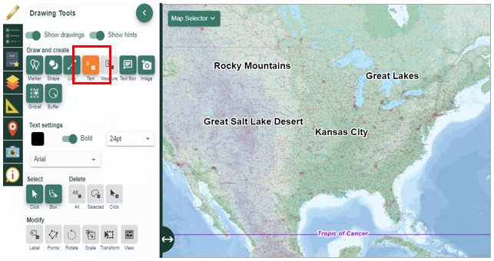

Contents
Digimap for Schools Geography Resources 3
Content and Curriculum Links 3
Introductory discussion 5
Task 1: Two continents – North America and South America 6
Task 2: Investigating the Amazon Basin 8
Task 3: Investigating Borders 10
Task 4: North America (focus on the USA) 13
Copyright 16
Acknowledgements 16

Digimap for Schools Geography Resources
These resources are a guide for teachers to demonstrate to the whole class or direct individual students as appropriate. Each activity has several ideas within it that you can tailor to suit your class and pupils.

https://digimapforschools.edina.ac.uk/

Content and Curriculum Links

Introduction
These activities using Digimap for Schools are designed for children in Y5 – Y6. Use will depend on the ability of the children and how much experience they have had using DfS.
The activities assume that children have used DfS in Y3 and Y4, maybe in the context of Britain and Europe. Tasks 1 and 2 might be used with Y5 and Tasks 3 - 4 with Y6. Some of the activities could be done on the large screen, as a class, led by the teacher.

Level |  | Context | Location
Primary |  | Exploring physical and human features of a continent | North and South America
Purpose and aims: | - locate North and South America (including the location and countries of Central America)  - locate and label some countries from both continents  - locate and label the surrounding oceans/seas e.g. Pacific, Atlantic, Caribbean  - locate some significant physical features e.g. The Andes, The Rocky Mountains, The Amazon Basin, The Great Lakes  - locate some significant human features e.g. Panama Canal and The Mexico/USA border  - measure some significant features e.g. the area of the Amazon Basin to give an idea of its vast size compared to the UK.  - investigate a range of places from the most southernmost point in South America to the north of North America to gain an understanding of latitude and longitude (including the Tropics of Cancer and Capricorn, Arctic and Antarctic Circles and the Equator)
Skills | Digital mapping skills  - Search for places  - Zoom in and out (larger scale to smaller scale maps)  - Select different types of world maps i.e. Atlas (physical) and World Boundaries (political)  - Add markers and labels  - Describe features on the map using the key  - Investigate map overlays i.e. latitude and longitude  - Use measurement tools
Curriculum links (England) | - locate (some of) the world’s countries, using maps to focus on North and South America, concentrating on their environmental regions, key physical and human characteristics, countries, and major cities  - name and locate (some) cities of the United Kingdom  - identify the position and significance of latitude, longitude, Equator, Northern Hemisphere, Southern Hemisphere, the Tropics of Cancer and Capricorn, Arctic and Antarctic Circles  - use maps, atlases, globes and digital/computer mapping  The activities in this unit could be used as an introduction to the more specific/detailed study of a region in North or South America required at KS2.

Introductory discussion
- Discuss with children what they know already about The Americas.
- Do they understand the difference between ‘America’ and the ‘United States of America’ (USA)?
- Do they know some of the countries from the North American region (Canada, USA, Greenland, Mexico) and from South America?
- What about the regions of Central America and the Caribbean?
- What have they heard about these regions, their countries and their people from the news and elsewhere?
- Where exactly are the Americas?
- What are some key physical characteristics of North and South America? (Mountains, rivers, weather etc.)
- Do they know of any key regions and cities?
- Can they find North America and South America on a globe? What do they notice?
- Is there anything that surprises them about the two continents?
- Which oceans and seas surround the Americas?
- What questions do they have about North and South America?

Misconceptions
Many children may have stereotyped or preconceived ideas about North America, South America, USA etc. These may be either positive or negative but need to be challenged to ensure they do not influence future learning.

Using images alongside maps
To avoid a stereotypical view of (countries within) North and South America it is very important to use a wide range of images, alongside maps and globes, when studying these continents (or indeed any other regions). This will help children understand the vastness and diversity of the continents as well as help to address any misconceptions they may have of The Americas and their people.

Task 1: Two continents – North America and South America
- Locate North and South America on the map.
- Open Overlays.
- Turn on the ‘Major Lines of Latitude’ Overlay.
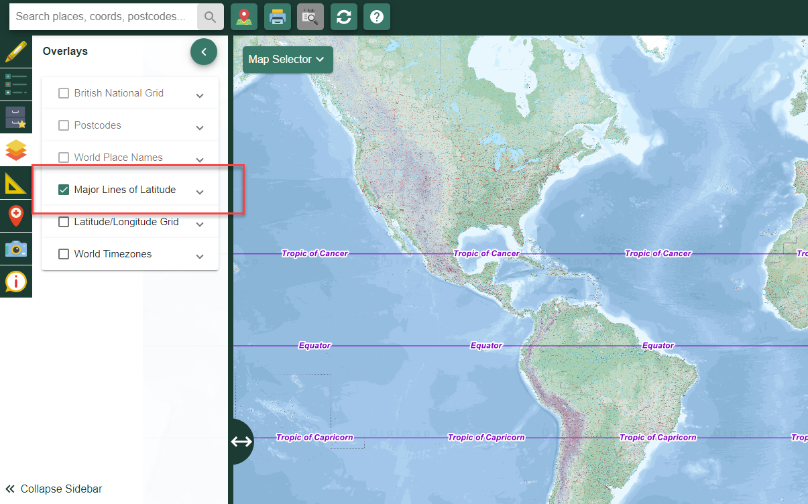
- North America is located mainly between which two major lines of latitude?

- Through which South American countries does the Equator pass?

- Select the ‘Drawing Tools’ and add some place labels to your map e.g. North America, Atlantic Ocean, Pacific Ocean etc.
- Zoom in.
- Use the map key (available in the sidebar on the left) to identify and label other physical and human features e.g. Andes, Rockies, Great Lakes, Caribbean Sea, major cities etc.
- Save or print your map including all your labels. Add more labels to your paper map later.

Task 2: Investigating the Amazon Basin
- Search for Brazil in South America.
- Turn on the Major Lines of Latitude Overlay to see the Equator and Tropics of Cancer and Capricorn. 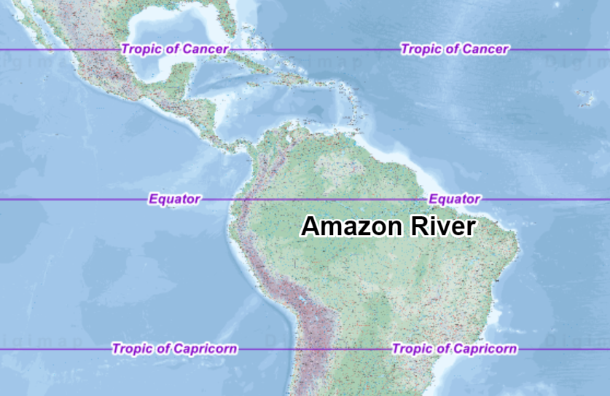

- Locate the River Amazon which runs from the Andes Mountains in the west towards the Atlantic Ocean, just south of the Equator.
- Zoom in to view the mouth of the river Amazon. What do you notice?

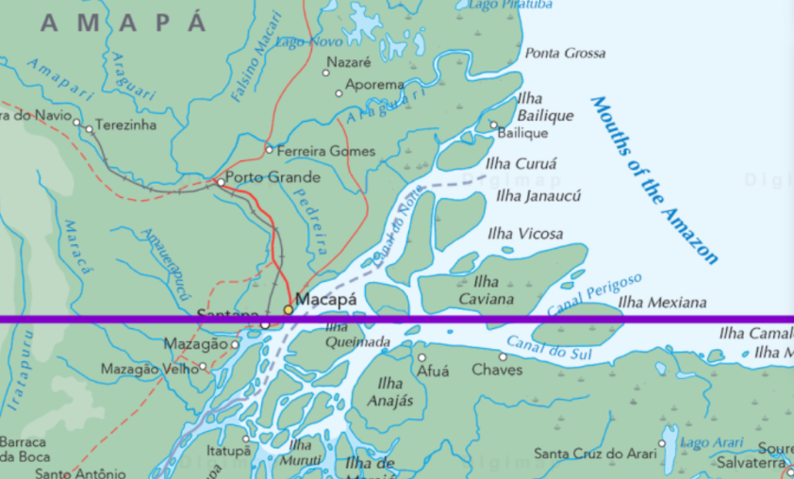
- Follow the Amazon inland, through Brazil, noticing the many tributaries and the vast area that the river covers.
- Go to the Measurement tools, select ‘Area’ and draw a shape covering the Amazon Basin (approximate is ok). How many square kilometres does the basin cover?
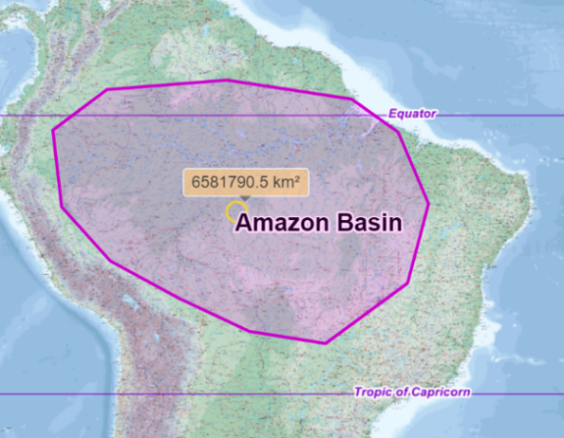
- Switch the map selector from ‘Atlas’ to ‘World Boundaries’. Name some of the countries in the Amazon Basin.
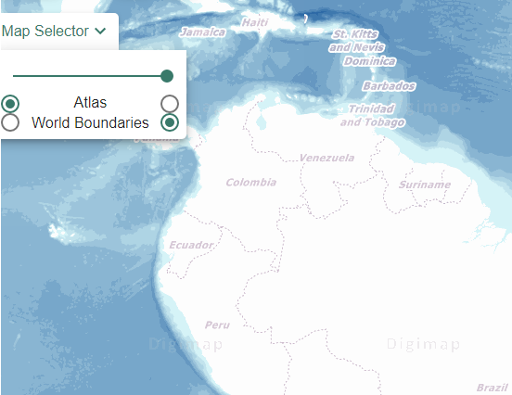
- Now measure the area covered by Great Britain. How does this compare with the area of the Amazon Basin?
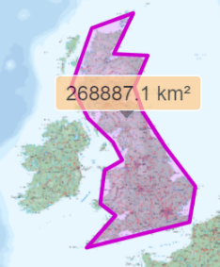

Task 3: Investigating Borders

(Panama Canal in Central America, and the Mexico-USA border)
- Search for the country of ‘Panama’ in Central America. Make sure to also select Places (world) under the search box to find the right Panama.

- Open ‘Overlays’ and switch on ‘Major Lines of Latitude’ and ‘Latitude/Longitude Grid’.
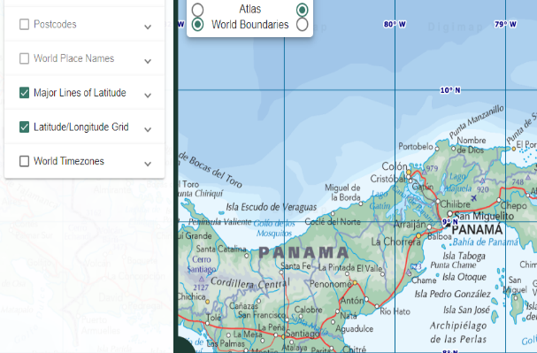

- The Panama Canal is located between 79° and 80° West and between 9° and 10° North.
  - This is 79° West of Greenwich in which city?

  - This is 9° - 10° north of which major line of latitude?

- Zoom in.
- Open the Drawing Tools and mark the canal on your map.
- Zoom out to show more of the map.
- The Panama Canal allows ships to navigate between which two oceans?
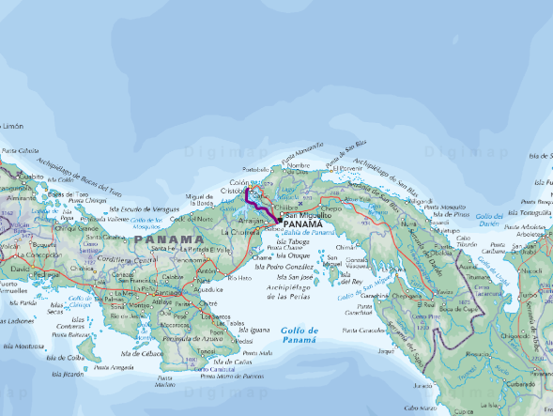
- Using the scale bar calculate (approximately) the length of the Panama Canal.

- Click Map Selector to toggle between Atlas (physical map) and World Boundaries (political map) to view the countries of South America.
- How might ships have travelled from one ocean to the other before the canal was built?
- Click on Collapse sidebar to see more of the map.
- Draw and label a possible route on your map.

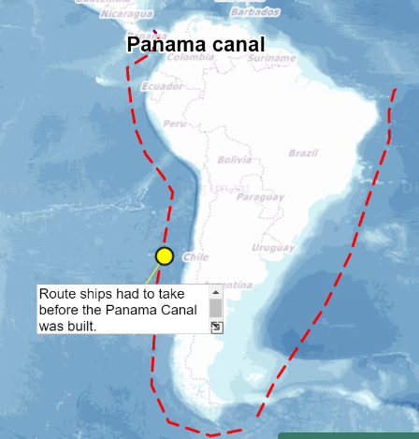
- On your map now travel north to the border between Mexico and the USA. (Or search for ‘Tijuana’ in Mexico.)

- Follow the border east to the Gulf of Mexico. What river does the border follow for much of the way?

- Use the Measurement Tools to measure the distance of the border. Why might your measurement be a lot less than the actual distance?

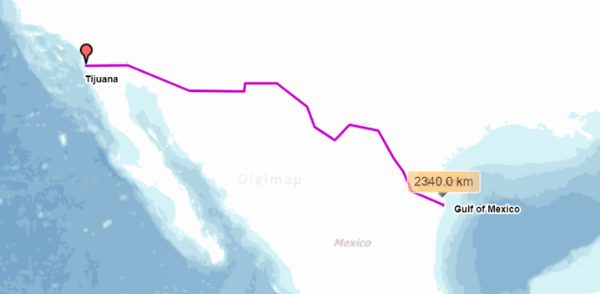

Task 4: North America (focus on the USA)
- Navigate to North America. Locate the main countries: Canada, USA, Greenland and Mexico.
- The United States of America comprises 50 states including California, Florida etc. Two states do not have a land border with the rest of the states. Which are they?
    - One is a set of islands in the Pacific Ocean (around 20° North, 156° West).

    - and the other is in the far northwest near the Arctic Circle (60° - 70° North, 140° - 170° West).
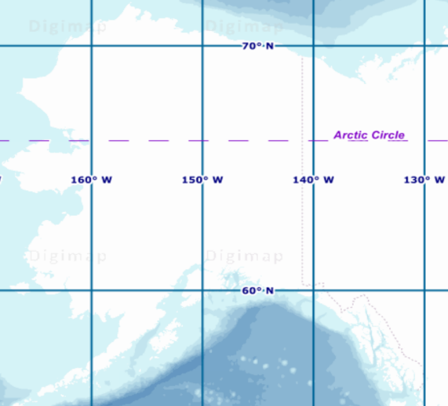
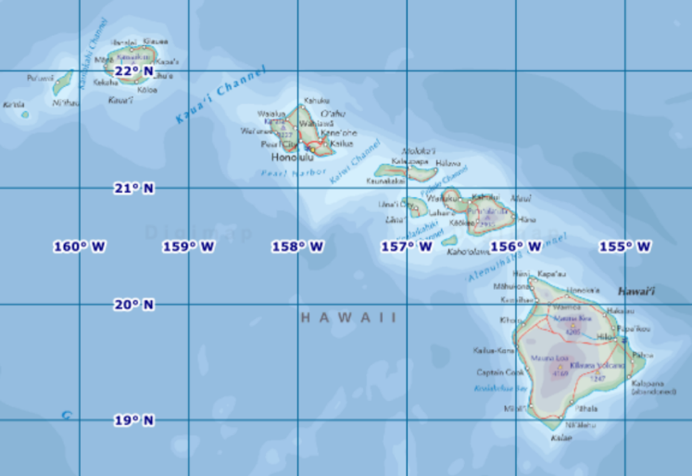
- Search for the capital city of the USA, Washington DC.
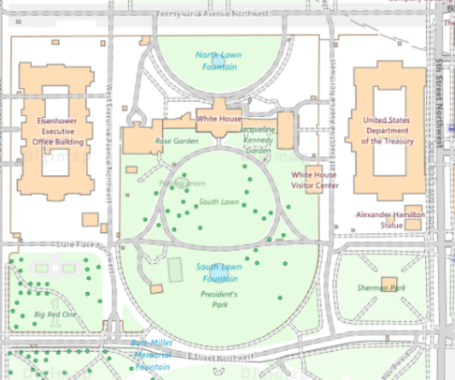
- Can you identify some significant features within the city e.g. The White House?
- Use the map Key to identify further features in the city. What do you notice?

- Label your map and print it off including the key (legend).
- Switch on the Overlay Latitude/Longitude Grid.
- Travel west from Washington DC. Identify the places in the table below. Fill in the gaps.

Name of place or feature | Degrees W (Longitude) | Degrees N (Latitude) | Description
Washington DC | 77° | 39°
 | 87° 36’ | 41° 54’
 | 113° | 36° 14’
 | 115° | 36°
San Francisco

- Plan your own trip across the USA or Canada. What places will you travel through? Record their latitude/longitude.

Copyright
©EDINA at the University of Edinburgh 2020
This work is licensed under a Creative Commons Attribution Non-Commercial Licence 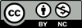

Acknowledgements
© CollinsBartholomew Ltd (2019) FOR SCHOOLS USE ONLY
© Crown copyright and database rights 2020 Ordnance Survey (100025252). FOR SCHOOLS USE ONLY.
Aerial photography © Getmapping plc. Contains OS data. FOR SCHOOLS USE ONLY.
Historic mapping courtesy of the National Library of Scotland. FOR SCHOOLS USE ONLY.

