Treasure Hunt
Paula Owens
Geography Teaching Resource
Primary
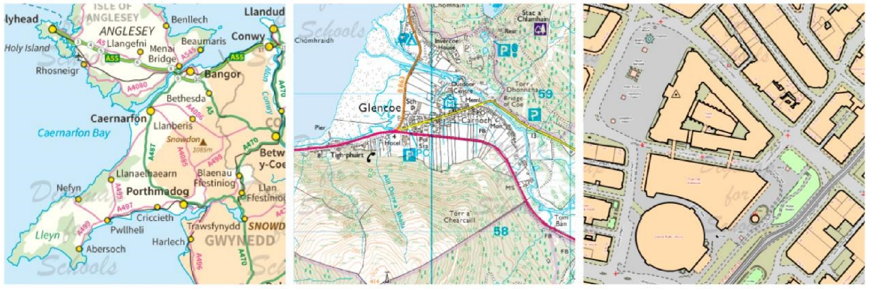

Contents
Contents 2
Content and Curriculum links 3
Activity 4
Tasks 4
Web links 4
Activity: The Kendal Mystery Treasure Trail 5
Activity: St David’s Secret Sword Treasure Trail 6
Activity: The Norwich Knowledge Treasure Trail 7
Taking it further 8
Copyright 8
Acknowledgements 8

Content and Curriculum links

Activity
Pupils use given clues to follow direction on maps and find out where the ‘treasure’ is hidden. Then they create a treasure trail of their own.

Level | Context | Location
Primary | Reading maps | Given examples are for Kendal in Cumbria, St David’s in Pembrokeshire and Norwich in Norfolk but the idea can be applied anywhere.

Knowledge | Reading and following directions on maps/knowing that Grid Reference numbers are used to pinpoint locations/using the Grid Reference tool/Using four and eight cardinal points.
Curriculum links (England) | Use the eight points of a compass, four-figure grid references, symbols and key (including the use of Ordnance Survey maps) to build their knowledge of the United Kingdom.
Curriculum links (Wales) | Identify and locate places using maps, follow directions using maps.
Scottish Curriculum for Excellence | Social Studies Outcomes: People, Place and Environment: 2-13a, 2-14a

Activity
Pupils use given clues to follow direction on maps and find out where the ‘treasure’ is hidden. Then they create a treasure trail of their own.
Treasure trails help children to read and use maps with greater confidence. Digimap for Schools offers maps at a range of scales and the large-scale maps are very detailed. This helps pupils to get better at recognising map features and grid reference numbers as they learn how to take virtual ‘walks’ through the landscape.
There are three ‘Secret Treasure’ missions to choose from. Each trail has a ‘secret code’ to find the start, in the form of a grid reference number. Pupils work alone, or with a partner, to read the clues and follow the trail on the map. They need to think carefully about which way north, south, east or west is on the map.

Tasks
- Pupils read the secret treasure mission. Once they have opened Digimap for Schools, they enter the secret code (grid reference number) into the search box and search the map that appears for the place mentioned in clue 1.
- Following the clues should lead them to the treasure; they click on the map where they think it is and copy down the grid reference number.
- (If some pupils are able and willing to attempt using eight-figure grid references, you can afford to be generous and allow some difference in the last digit to the given answer).

Web links
National Grid FAQs
http://www.ordnancesurvey.co.uk/support/the-national-grid.html
Using grid references, interactive guide
https://www.ordnancesurvey.co.uk/mapzone

Activity: The Kendal Mystery Treasure Trail
Name
The Kendal Mystery Start NY 2800 2391 End NY 2644 2451
A valuable, magical recipe for Kendal Mint Cake has gone missing. Only these clues remain to say where it was hidden. Can you find it?
- Select Overlays and check the box next to British National Grid.
- Put this secret code number in the search box – NY28002391.
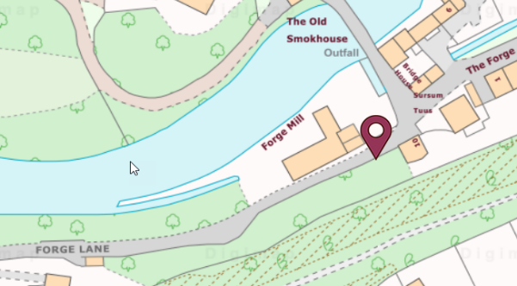

Clues:
- You are at the end of Forge Lane.
- Go East until you meet the junction of Penrith Road then go West on Penrith Road and follow the road to Calvert’s Bridge.
- Cross the river. What is the name of the river you have just crossed?
- Head North until you come to a farm with the same name as the river.
- From this farm, head West across fields until you reach a lane with a name that reminds you of eating. You are near a junction.
- Turn West at this junction and keep going to a place that looks after sick people.
- Now, head North towards a roundabout. Cross over and keep heading North and look for the caravan park.
- The recipe is in the caravan park, hidden in the caravan that is furthest South.
- Open the Drawing Tools. Select the Place Grid Reference tool. Click on the caravan to get the secret code.
Answer

Extension activities
Why not draw your own treasure map of this location? Either create a digital map using Digimap for Schools or a draw a map by hand.

Activity: St David’s Secret Sword Treasure Trail
Name
St David’s Secret Sword Start SM 7517 2543 End SM 7633 2395
A magical sword from ancient times was lost long ago at St David’s. But now some clues have been found. Can you use the map to find it?
- Select Overlays and check the box next to British National Grid.
- Put this secret code number in the search box - SM75172543.
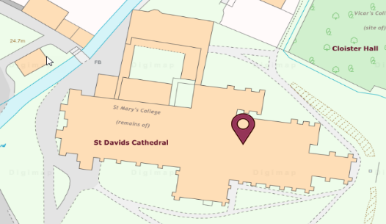

Clues
- You are in a cathedral that is very beautiful. You want to look around but there’s no time! Get to the High Street as quickly as you can.
- Head East on the High Street, past the Police Station and past the hotel until you come to a crossroads and car park.
- Turn right at the crossroads and head south along this road. Keep going until you come to a place where people stay in tents.
- Take care! You are near a quarry! Find the cliff path and follow the top of the cliff around the bay to the East. There is a sandy beach down below with boulders – don’t fall down!
- Keep going along the cliff path, it takes you South towards the headland, where there was an ancient settlement.
- Keep going and don’t stop to look at the natural arch on the way! You must find a cave at the most southerly point of the headland and abseil down the cliffs to it. The sword is hidden in there.
- Open the Drawing Tools. Select the Place Grid Reference tool. Click on the cave to get the secret code.

Answer

Extension activities
Why not draw your own treasure map of this location? Either create a digital map using Digimap for Schools or a draw a map by hand.

Activity: The Norwich Knowledge Treasure Trail
Name
The Norwich Knowledge Start TG 2423 0929 End TG 2318 0852

The Norwich Knowledge is a myth as old as time. Legend has it that if you find the Norwich book of Knowledge you will know the answer to any question in the world. But it hasn’t been seen for hundreds of years. Can you find it?
- Select Overlays and check the box next to British National Grid.
- Put this secret code number in the search box - TG24230929.

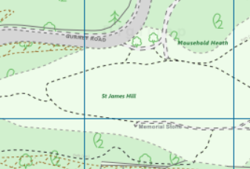

Clues
- Your quest begins on a hill named after a famous saint. But you haven’t got time to admire the view! You need to find the road that will take you to the nearest police station near the roundabout.
- Once at the police station, look out for the River Wensum – it’s to the south-west of you but be careful crossing the roads!
- Follow the river southwards until you can see the railway station and another police station. Just before the station there is a bridge. At this bridge you will find a road fit for royalty.
- Head westwards along this road for a little more than half a kilometre until you come to the remains of a building where Kings probably stayed.
- There is a museum on this site. Little do they know that hidden on their bookshelves is the Book of Knowledge!
- Open the Drawing Tools. Select the Place Grid Reference tool. Click the centre of the museum to get the secret code.
Answer

Extension activities
Why not draw your own treasure map of this location? Either create a digital map using Digimap for Schools or a draw a map by hand.

Taking it further
Ask pupils to draw their own map to show the treasure trail they have just followed. They could do this by annotating the map using the Digimap tools.
- Ask pupils to draw their own map to show the treasure trail they have just followed. They could do this by annotating the map using the Digimap tools.
- Ask pupils to write their own treasure mystery trail using the same format.
- Use the same start and finish locations used in the treasure trail but find a different route and describe it with clues.
- Do some fieldwork in your locality and using maps, pinpoint good locations for a trail. Back in class, devise and write clues for routes. Illustrate with locally taken photographs and hand drawn maps.

Copyright
©EDINA at the University of Edinburgh 2016
This work is licensed under a Creative Commons Attribution-Non Commercial Licence

Acknowledgements
© CollinsBartholomew Ltd (2019) FOR SCHOOLS USE ONLY.
© Crown copyright and database rights 2020 Ordnance Survey (100025252). FOR SCHOOLS USE ONLY.
Aerial photography © Getmapping plc. Contains OS data. FOR SCHOOLS USE ONLY.
Historic mapping courtesy of the National Library of Scotland. FOR SCHOOLS USE ONLY

