Using Aerial Imagery
  - Quick ideas: school grounds
Paula Owens
Geography Teaching Resource
5 – 7 years

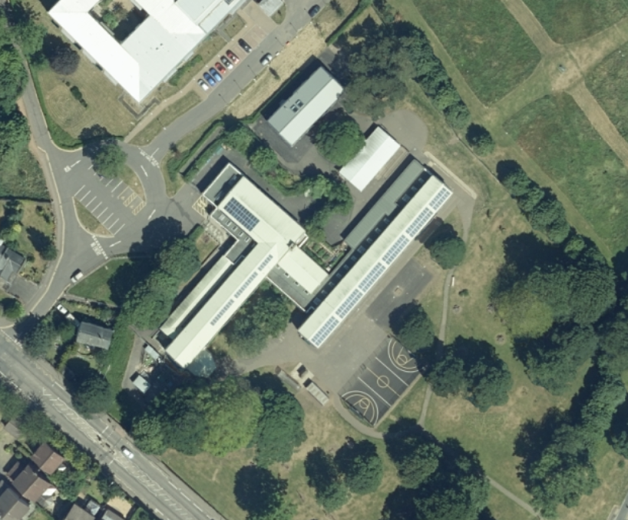

Contents
Digimap for Schools Geography Resources 3
Content and Curriculum Links 3
Identifying features 4
Match the Image 4
Image Search 4
A place to…? 4
Measuring the School Grounds 5
What goes on here? 5
Map Match 5
Fieldwork 5
Copyright 6
Acknowledgements 6

Digimap for Schools Geography Resources
These resources are a guide for teachers to demonstrate to the whole class or direct individual students as appropriate. Each activity has several ideas within it that you can tailor to suit your class and pupils. Some resources contain worksheets for direct distribution to pupils.
https://digimapforschools.edina.ac.uk/

Content and Curriculum Links
Level | Context | Location
5 – 7 years | Using aerial imagery and fieldwork | School grounds and various

Knowledge | Using aerial imagery with maps
Curriculum links (England)  Geography KS1 | - use aerial photographs and plan perspectives to recognise landmarks and basic human and physical features  - use simple fieldwork and observational skills to study the geography of their school and its grounds and the key human and physical features of its surrounding environment
Curriculum links (Wales)  Knowledge and Understanding of the World | - use and make simple maps, to find where places are and how places relate to other places  - Identify natural features, e.g. rivers, hills, beaches, and the human features, e.g. buildings, roads, bridges, of their own locality
Scottish Curriculum for Excellence  Social studies  Experiences and outcomes | - I can describe and recreate the characteristics of my local environment by exploring the features of the landscape  SOC 1-07a

Identifying features
Locate your school using a post code search. Select an appropriately scaled OS map that shows the school grounds and which allows you to switch between this and the aerial mapping. Ask children to identify, name and label features found on the aerial view using the Drawing Tools. Develop the labelled aerial view of the school and grounds into a large wall display using collage or paint and add to the vocabulary. You could also later add measurements and photographs. Be sure to add the compass points to the display to get children thinking about orientation.

Match the Image
Get children to take their own photographs of prominent features in the school grounds (or in the surrounding locality) and then find the corresponding feature on the aerial image view. Add the photograph to the relevant feature using the Add image tool. Then toggle to OS map view to see what the map says and how the feature is shown.

Image Search
You can also use the Image Search tool in Digimap for Schools to display images on your map (Geograph is an online library of images of the UK that is open to anyone for contributions).
Select the Image Search option from the sidebar. Enter your search terms to find matching images. NOTE: you can enter an asterisk (*) to see all available images at a location (but only in the 5 most zoomed in maps).

A place to…?
play football? | have a picnic? | watch wildlife?
meet a friend? | sit in the shade? | meet a friend?
- Look at an aerial image of your school and grounds and discuss the landscape and its features with children.
- Ask children to identify the best place to do a particular activity.
- The children could make up their own list. Once the list of activities and corresponding ‘best’ places have been identified, these can be marked on the aerial image and labelled using the Drawing Tools.
- Switch back to OS map view and save the map. The class could compile one map on which they are all agreed and this could be the stimulus for a piece of writing about ‘My School’.

Measuring the School Grounds
How big is the school and its grounds? How much of the school ground is playground? How much is grass? How much is covered by trees? How much area does the school roof cover? Using the aerial view, identify different types of ground use and use the ‘Area Map’ tool to click around the extent of each area. Younger children will be able to visually appreciate the shapes and comparative size of different areas but they could also select the Measurement Tools and select an area to get a measurement in e.g. either square metres or kilometres.

What goes on here?
Use an aerial view of the school and surrounding area to investigate evidence of everyday human activity. Having found the appropriate map and toggled through to the corresponding aerial image, select the Buffer Tool from the Drawing Tools (with the radius set to 0.5 kilometres) and ask pupils to click on their school (or their house) to set the centre of the ‘buffer zone’. Investigate and discuss the view within the buffer zone. Can any people be seen? What about cars and other traffic? How busy is it? Is parking a problem here?
This could then be repeated with another school or at another location to compare different places. For example, children might compare traffic volume in an urban and rural school setting. Are there any clues in the image that reveal what the season is or the time of day? Why might this make a difference to how busy an area seems to be?

Map Match
Print off and laminate a map and the corresponding aerial image of the school grounds at the same scale. Cut each up into equal sections e.g. 9 (3 x 3) or 12 (4 x 3). Share the map cards out between a small group of children, giving them just three or four each. Spread the aerial images face down on a table. The children take it in turns to select and turn over an image. If it matches one of their map pieces they can keep it. If not, they replace the card upside down. The winner is the one who matches all their cards first. In a simpler version, children just work collaboratively as a team to match map and aerial views correctly. They could compete to do this quicker than other teams.

Fieldwork
As with all mapping activities involving the school grounds, or any locality you can easily access, it is helpful to take young children outside to explore a terrain at first – hand, noting significant features in multi – sensory ways. Take a compass with you to talk about direction. Reinforce the names of geographical features too and their relative position to other features. Familiarising young children with aspects of the real world in tandem with digital mapping activities is a vital part of successful map work.

Copyright
©EDINA at the University of Edinburgh 2016
This work is licensed under a Creative Commons Attribution-Non Commercial Licence

Acknowledgements
© CollinsBartholomew Ltd (2019) FOR SCHOOLS USE ONLY
© Crown copyright and database rights 2020 Ordnance Survey (100025252). FOR SCHOOLS USE ONLY.
Aerial photography © Getmapping plc. Contains OS data. FOR SCHOOLS USE ONLY.
Historic mapping courtesy of the National Library of Scotland. FOR SCHOOLS USE ONLY.

