What’s the quickest way to school?
Paula Owens
Geography teaching resource
Primary

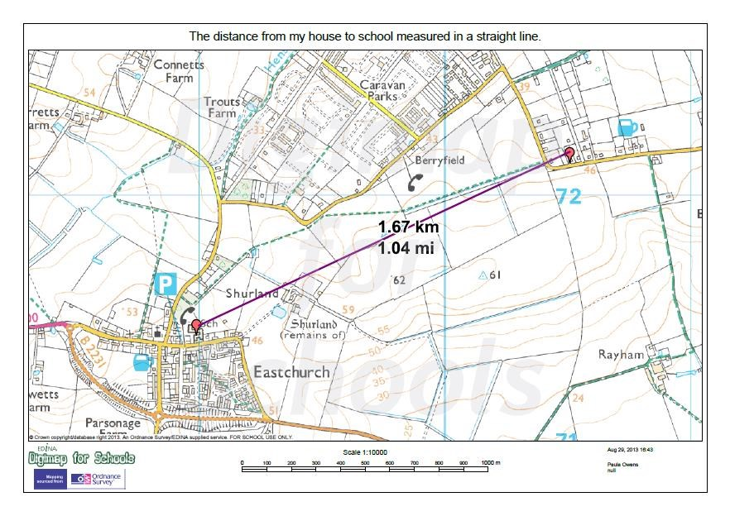

Contents
Digimap for Schools Geography Resources 3
Content and Curriculum Links 3
Summary 4
Introduction 4
Main activity 4
Tasks 5
Taking it further 7
Copyright 9
Acknowledgements 9

Digimap for Schools Geography Resources
These resources are a guide for teachers to demonstrate to the whole class or direct individual students as appropriate. Each activity has several ideas within it that you can tailor to suit your class and pupils. Some resources contain worksheets for direct distribution to pupils.
https://digimapforschools.edina.ac.uk/

Content and Curriculum Links
Level | Context | Location
Primary | Investigating alternative routes to school | Home location

Knowledge | Plotting simple routes. Using measuring tools. Recognising simple map features. Beginning to use a key.
Curriculum links (England) | Study the geography of the school and the key human and physical features of its surrounding environment.
Curriculum links (Wales) | Knowledge and Understanding of the World: Learn about distance and how to follow directions and routes.
Scottish Curriculum for Excellence | Social Studies Outcomes: People, Place and Environment: 0-07a, 1-07a, 1-14a,

Summary
Investigating different routes to school and why and how some routes are shorter than others. Pupils can mark out and approximately measure their routes to school.

Introduction
All pupils have experience of getting to school using different routes and methods of transport. Digimap for Schools allows these routes to be measured and plotted, helping children to make connections between distance and type of travel and to begin to recognise patterns in the landscape.
Some useful questions to explore before starting the activity:
- How do you get to school and why do you travel in this way?
- How long does it take you to get to school?
- How far do you think your journey is?
- What do you see along the way?
- Do you always use the same route?
- What route would you take if you were a bird and could fly straight to school?

Main activity
Pupils will imagine that they are a bird and able to fly directly to school in a straight line from their house ‘as the crow flies’. Pupils draw a line joining their home and school, then measure and record how far this is.
They then plot a line to school from home by following the route that they usually take, and measure this. Then they will compare the two.

Tasks
- Open Digimap for Schools and help pupils find a map that shows both their home and school. They should zoom in as far as they can without losing sight of these two places.
- Open the Drawing Tools from the sidebar on the left. Select a red pin marker and add one at each location.
- Keep the Drawing Tools open. Select Draw Line.
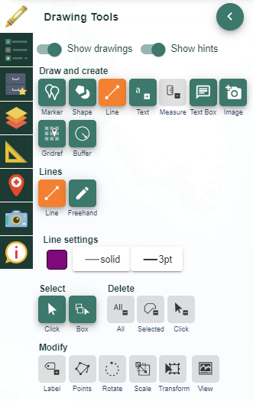

- Select the colour, style and weight of line you want to use. The default line option is solid purple which shows up well.
- Now draw a line. Select the house to start, draw a line to the school and double click to finish.
- Add a measurement label to your line. Just select the measurement tool then select your line. The result will be displayed on your line in KM.

- Now pupils will find their actual route to school. Repeat the process as before but this time, select a different colour and line-style before you begin. As the line is drawn, click each time you change direction. Double click to finish.

- Open the measurement tool as before and select this route to measure it. Calculate the difference between the two distances.
- Finally, add some labels using the Add label option. Remember to choose the text size, font and colour before placing the label. Labels might include.
- My house
- Name of school
- As the crow flies
- My route to school
- Discuss how and why the two distances are different, thinking about features in the landscape, especially barriers and boundaries.
- Why can’t you go directly to school by travelling in a straight line?
- Why can’t roads always follow the quickest route?
- Why can’t we even walk to some places in a straight line?
Use the maps to discuss features you pass on your way to school on the usual route and what extra things you might see if you could fly in a straight line. Use the map key to help identify some of these.

Taking it further
Create a class resource showing how many pupils live within various distances of the school.
- Use the Buffer tool.
- Draw point buffers at 0.5, 1 km and 2 km (or more) around your school.
  - Line settings - select an outline colour that will show up well (such as dark blue) and a solid line style at 3 or 4 pt.
  - Fill settings – you don’t want any colour here. Ensure the transparency slider is all the way to the left, see red circled area on image below:
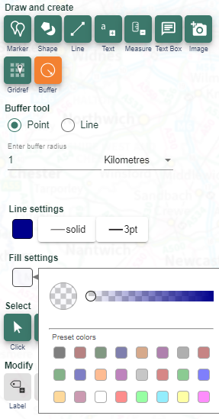
- You will need to zoom out to see the rings.
- You could also add labels to the buffers to show their distance from school.
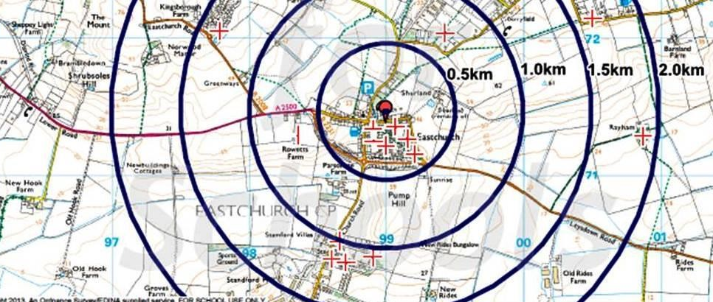
- Ask every pupil to add a marker indicating where they live.
- Discuss the results with the class.
Write a story from a bird’s eye perspective about a journey to school taking the direct route.
- Search the map to find examples of places that are very close together ‘as the crow flies’ but which are separated by long distances because of features in the landscape such as water; for example: Minehead and Cardiff. Discuss why bridges are so important.
- Investigate the safest routes to school for walkers. Decide how you can encourage parents to car-share or walk instead of driving.
- Look at aerial views of your route to school. What time of year were the photos taken? How can you tell?
- Look at the 1890s map of your route to school. How would you get to school when here were no cars?

Copyright
©EDINA at the University of Edinburgh 2016
This work is licensed under a Creative Commons Attribution-Non Commercial Licence

Acknowledgements
© CollinsBartholomew Ltd (2019) FOR SCHOOLS USE ONLY
© Crown copyright and database rights 2020 Ordnance Survey (100025252). FOR SCHOOLS USE ONLY.
Aerial photography © Getmapping plc. Contains OS data. FOR SCHOOLS USE ONLY.
Historic mapping courtesy of the National Library of Scotland. FOR SCHOOLS USE ONLY.

