Where do I go in a Week?

Home range: the near and wider locality

Paula Owens

Geography Teaching Resource

Primary
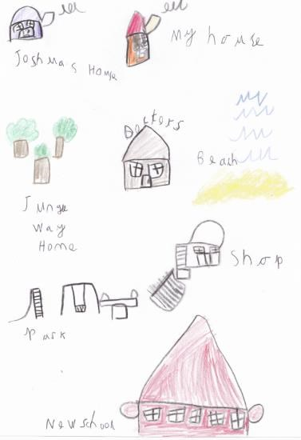

Contents
Digimap for Schools Geography Resources 3
Content and Curriculum Links 3
Activity 3
Introduction 4
Main activity 4
Zoom practise 6
Taking it further 6
Web links 7
My places worksheet 9
Copyright 10
Acknowledgements 10

Digimap for Schools Geography Resources
These resources are a guide for teachers to demonstrate to the whole class or direct individual students as appropriate. Each activity has several ideas within it that you can tailor to suit your class and pupils. Some resources contain worksheets for direct distribution to pupils.

Content and Curriculum Links
Level | Context | Location
Primary | Home range: the near and wider locality | Home locality

Knowledge | Locating places using a map knowing that scale is used in maps to show different levels of information and that large scale maps show small areas, whilst small scale maps show large areas of land
Curriculum links (England) | Local area study, describe the location of features on a map, use geographical vocabulary
Curriculum links (Wales) | Knowledge and Understanding of the world: use and make simple maps, to find where places are and how places relate to other places  Geography: use maps, and ICT to find and present locational information
Scottish Curriculum for Excellence | Social Studies Outcomes: People, Place and Environment 1-07a, 2-07a, 2-10a, 1-14a, 2-14a

Activity
Pupils make a sketch map of places they usually go to in their everyday lives during the course of a week. Then, ordering these by distance from their home they try to locate them on a map starting with a large-scale map and then zooming out gradually until all the places have been found.

Introduction
There are regular places that we might visit during the course of a week. For pupils this will include school and possible other places such as: after school clubs; informal play spaces; friends’ houses; parks; doctor’s surgery; shops; relatives’ houses, and places of worship. Pupils of this age will not have a great home range on their own but may visit places further away in the company of their parents or other relatives.
Task pupils to use the zoom tool to develop their awareness of how maps at different scales work.

Main activity
- Tell pupils about places you might have been to in a typical week from your home. Include obvious examples such as going to school, visiting the local or more distant shops, going for a walk, visiting friends and family and so on. Name the places you have visited.
- Ask pupils to do a quick sketch diagram to show the places they usually visit.
- Share some of the pupils’ ideas and discuss which trips were made on foot, which by car, bus, train or other forms of transport.

Nearest to/furthest from my home
Joshua’s house
Jungle way home
Doctors
Beach
Shop
Park
School

- Use pupils’ drawn maps to discuss which places are nearest to them and ask if they can order them from nearest to furthest from their home.
- Explain that they are going to investigate how far they will have to zoom out on a map from their home view to be able to see all of the places they have mentioned on the screen.
- Model using the scale bar to zoom in and out on the map and count the levels as you do this.

- Use plus to zoom in.
- Use minus to zoom out.
- Move the bar up or down to move through the scales.
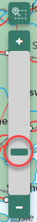
- Use the zoom to maximum extent to zoom out as far as possible.
- There are 18 levels of zoom.
- Let pupils practise counting the levels, starting from a ‘zoomed’ out view.

Zoom practise
- Ask the pupils to open a Digimap for Schools map and enter their home postcode to show where they live. Let them find their home and centre the map to show this.
- Without moving the map anymore ask them to practise zooming in and out as far as possible at this location.
- Now ask them to zoom right in as far as possible. Hand out the worksheet for them to write down the places drawn on their sketch map that they can find without moving the map.
- They should just search what they can see and tick off any places in that window.
- Zoom out one level and search again.
- Write down any new places you have found on the worksheet. Keep going one level at a time until all of the places drawn in your sketch map have been found.
- Discuss with children what they have found out and use the term ‘scale’ when you talk about ‘zooming in and out’. For example:
- How far did they need to zoom out before you found all of your places?
- Who needed to ‘zoom’ out the most?
- At which level of scale did they find most of the places? Was this the same for everyone?
- At which level of scale were local shops and supermarkets?
- Where were most of their play areas found?
- At which level were places they walked to?
- At which level were places they drove to?
- Encourage pupils to offer explanations for their findings.

Taking it further
- Watch ‘Zoom’ by Istvan Banyai, a short film that helps explain scale in a visual way.
- Ask pupils to add markers to their map to show the places they visit regularly. They could use different markers to show different kinds of places for example, shops, homes, schools, play areas and so on.
- Gather together a range of addressed envelopes with real addresses in the near and wider locality. Give these out to pairs of children and ask them to zoom in on the postcode and then to zoom out gradually, trying to identify each level of the address as they go.

Web links
- Zoom by Istvan Banyai www.youtube.com/watch?v=tyla9p-pteU (or use the Zoom book).
- Use www.safeshare.tv to format YouTube links for watching in schools.

Where do I go in a week?
Name
My postcode

You will need your drawn picture showing the places you usually visit:
- Use your postcode to search the map.
- Zoom in as far as you can by moving the slider to the top.
- Write down all of the places that you can find at this view that you have drawn on your map.
- Zoom out using the scale bar and look again – what can you see now?
- As you find your places on the map, you could tick them off your drawing.

My places worksheet
Level | What I see
1 | My home
2
3
4
5
6
7
8
9
10
11
12
13
14
15
16
17
18

Copyright
©EDINA at the University of Edinburgh 2016
This work is licensed under a Creative Commons Attribution-Non Commercial Licence

Acknowledgements
© CollinsBartholomew Ltd (2019) FOR SCHOOLS USE ONLY
© Crown copyright and database rights 2020 Ordnance Survey (100025252). FOR SCHOOLS USE ONLY.
Aerial photography © Getmapping plc. Contains OS data. FOR SCHOOLS USE ONLY.
Historic mapping courtesy of the National Library of Scotland. FOR SCHOOLS USE ONLY.

