Where do I live?

Paula Owens

Geography teaching resource

Primary

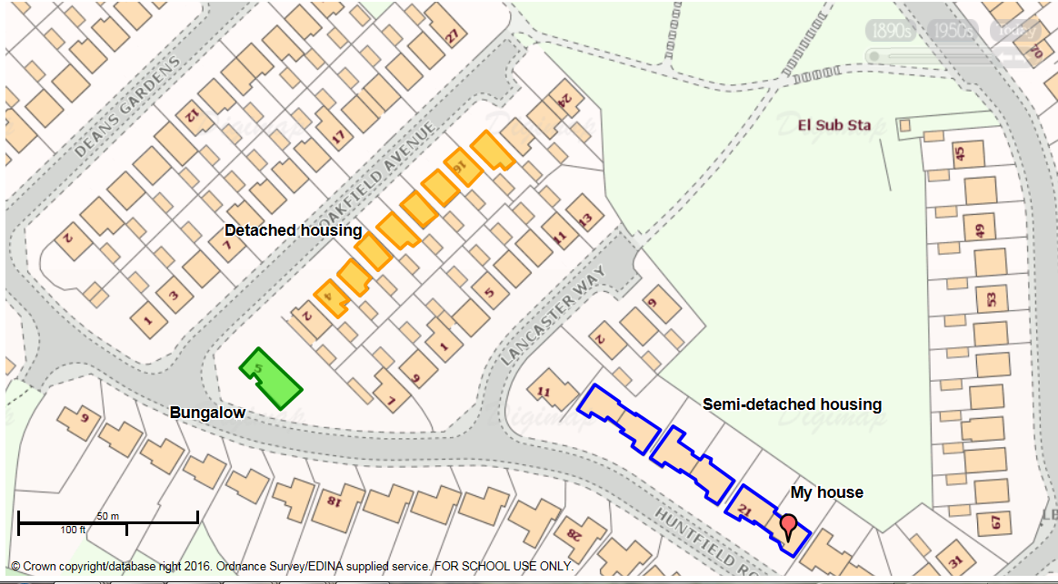
Contents

Digimap for Schools Geography Resources 3
Content and Curriculum Links 3
Introduction 4
Activity 4
Tasks 4
Taking it further 6
Copyright 7
Acknowledgements 7

Digimap for Schools Geography Resources
These resources are a guide for teachers to demonstrate to the whole class or direct individual students as appropriate. Each activity has several ideas within it that you can tailor to suit your class and pupils. Some resources contain worksheets for direct distribution to pupils.
https://digimapforschools.edina.ac.uk/

Content and Curriculum Links

Level | Context | Location
Primary | Locating own home address | Home locality

Knowledge | Locating and describing own address  Recognising buildings and roads on large scale maps  Annotating simple maps with labels and markers
Curriculum links (England) | Observe, measure and record human and physical features in the local area using a range of methods, including sketch maps, plans and graphs, and digital technologies
Curriculum links (Wales) | Knowledge and Understanding of the World: Learn about where own locality is; use and make simple maps.
Scottish Curriculum for Excellence | Social Studies Outcomes: People, Place and Environment: 0-07a, 1-07a, 1-14a, 1-11a

Introduction
Before starting the activity, it would be useful to do some preparation such as:
- Discuss pupils’ addresses and where they live, ensure they know their home postcode. (See web links for postcode finder). Discuss the postcode of the school and similarities between the school and pupils' home addresses. Find out if any pupils have the same postcode.
- Discuss types of housing using appropriate vocabulary for example, flats, terrace, bungalow, detached.
- Royal Mail Postcode finder may be useful: https://www.royalmail.com/find-a-postcode

Activity
This activity is designed for pupils working with individual access to Digimap for Schools. In this sequence of activities, pupils are going to find their home location, then use the ‘Draw an Area’ Tool from the Annotation Toolbar to mark their home before labelling it using ‘Place Marker’. They will then add other annotations to show different types of housing and where they play in the street and create and print a map.

Tasks
The following sequential tasks can be done over one or more sessions.
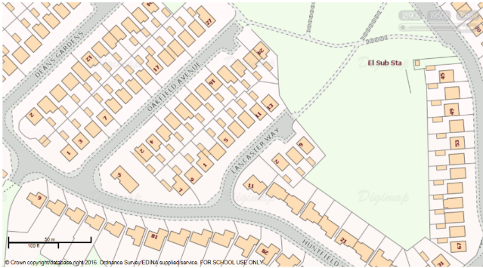
- Open Digimap for Schools, pupils enter their home postcode then, without moving the map, zoom in as far as they can and identify their home.
- Most houses can be identified by either numbers or names on the map at this scale but if not, pupils can make their best guess within a street.
- Pupils draw around their house and add a label.
- Open the Drawing Tools from the sidebar.

- 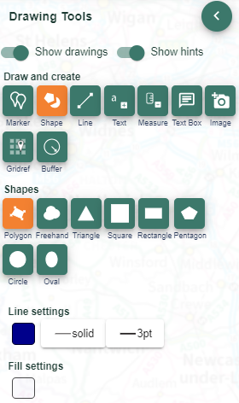Select the Draw Polygon tool from the ‘Draw and Create’ section.
- Find the boundary of the house on the map (including garden area if appropriate) and select one corner. Then select the next corner, then the next, until you have been around the property, then double click to finish.
- Select Add standalone label (first option in the draw and create area).
- Now select your text colour, font and size.

- Select the place on the map where you want the label and write ‘My House’.
- If you make a mistake, you’ll find Select and Delete options at the top of the Drawing Tools.
- Discuss what the zoomed in view shows and what different colours and shapes mean. Introduce the idea of a ‘Key’ which helps you unlock information on a map.
- Select Key from the sidebar. Point out one or two simple features on the key that can be easily related to the map such as buildings. Ask pupils if they can tell which buildings are terraced and which are detached and how they can tell.
- Practise using the Draw Polygon tool. Pupils identify and draw around building shapes (not including gardens this time) using different colours to show different kinds of house for example, detached, semi – detached and terraced.
- Save finished maps with a title.

Taking it further
Make a collaborative class map of addresses in which pupils take it in turns to add their postcode search to a map, adding a label with their name. Who lives the nearest/farthest from the school? Discuss the pattern of addresses – are they bunched up or scattered?
- Make a collection of photographs showing different features such as types of housing, roads, roundabouts, parks and so on, that can be found in the locality. Use web searches and image sites such Flickr as well as your own photographs. Use these to reinforce geographical vocabulary.
- You can use the Image Search tool in Digimap for Schools to find images (Geograph is an online library of images of the UK that is open to anyone for contributions).
- Open the Image Search tool from the sidebar and enter your search terms to find matching images. NOTE: you can also enter an asterisk to see all available Geograph images at a location (only in the 5 most zoomed in maps).

Copyright
©EDINA at the University of Edinburgh 2016
This work is licensed under a Creative Commons Attribution-Non Commercial Licence

Acknowledgements
© CollinsBartholomew Ltd (2019) FOR SCHOOLS USE ONLY
© Crown copyright and database rights 2020 Ordnance Survey (100025252). FOR SCHOOLS USE ONLY.
Aerial photography © Getmapping plc. Contains OS data. FOR SCHOOLS USE ONLY.
Historic mapping courtesy of the National Library of Scotland. FOR SCHOOLS USE ONLY.

