Where in the world is Russia?
Rowena Pryor
Geography teaching resource
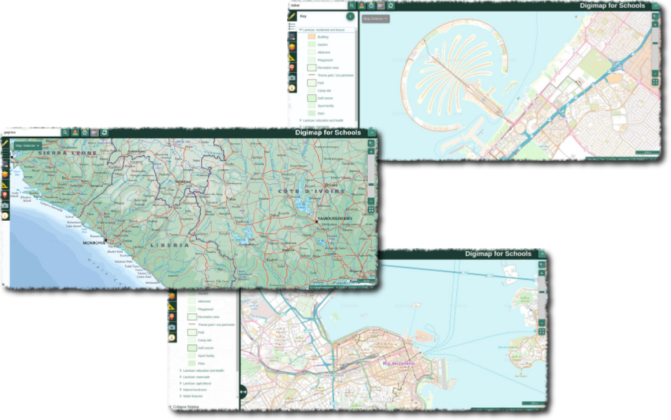
Primary – years 4-5

Contents
Digimap for Schools Geography Resources 3
Introduction 3
Content and Curriculum Links 3
Introductory discussion 5
Misconceptions 5
Using images alongside maps 5
Tasks 5
Task 1: Where in the world is Russia? 5
Task 2 Europe or Asia? 7
Task 3 East and West, North and South 9
Task 4 How big? How far? 11
Copyright 12
Acknowledgements 12

Digimap for Schools Geography Resources
These resources are a guide for teachers to demonstrate to the whole class or direct individual students as appropriate. Each activity has several ideas within it that you can tailor to suit your class and pupils.
https://digimapforschools.edina.ac.uk/

Introduction
- These activities using Digimap for Schools (DfS) are designed for children in Y4 – Y5. Use will depend on the ability of the children and how much experience they have had using DfS.
- The activities assume that children have used DfS in Y3, maybe in the context of Britain.
- Tasks 1 and 2 might be used with Y4 and Tasks 3 - 4 with Y5. Some of the activities could be done on the large screen, as a class, led by the teacher.

Content and Curriculum Links
Level | Context | Location
Primary | Investigating an unfamiliar country | Russia

Purpose and aims: | - locate Russia (the largest country in the world located within both Europe and Asia)  - locate and label Moscow the largest city (and capital) of Russia (a European capital)  - locate the Ural Mountains, running north to south from the Arctic Circle to north west Kazakhstan, which form part of the boundary between Europe and Asia.  - measure some distances within Russia (to gain understanding of its vast size) e.g. from Moscow to the Arctic Circle, from the Baltic Sea in the west to the Pacific Ocean in the east  - investigate the 11 time zones within Russia (to gain an understanding of its vast size)  - investigate/compare a range of places (e.g. Russia, UK, other countries and cities) to gain an understanding of latitude and longitude (including the Prime Meridian)
Skills | - Search for places  - Zoom in and out (larger scale to smaller scale maps)  - Select different types of world maps i.e. Atlas (physical) and World Boundaries (political)  - Add markers and labels  - Describe features on the map using the key  - Investigate map layers i.e. latitude, longitude and time zones  - Use measurement tools

Curriculum links  (England) | - locate the world’s countries, using maps to focus on Europe (including the location of Russia) concentrating on their environmental regions, key physical characteristics, countries, and major cities  - name and locate (some) cities of the United Kingdom,  - identify the position and significance of latitude, longitude, Equator, Northern Hemisphere, Arctic (and Antarctic) Circle, the Prime/Greenwich Meridian and time zones  - use maps, atlases, globes and digital/computer mapping  - The activities in this unit could be used as an introduction to the more specific/detailed study of a region in a European country required at KS2.

Introductory discussion
Discuss with children what they know already about Russia.
- What have they heard about Russia – from the news and elsewhere?
- Where exactly is Russia?
- What have they heard about people in or from Russia?
- What are the key physical characteristics of Russia? (Mountains, rivers, weather etc).
- Do they know of any key regions and cities?
- Can they find Russia on a globe?
- What do they notice?
- Is there anything that surprises them about Russia?
- Which countries border Russia?
- Which oceans and seas?

Misconceptions
Many children may have stereotyped or preconceived ideas about Russia. These may be either positive or negative but need to be challenged to ensure they do not influence future learning.

Using images alongside maps
As very few children will have visited Russia it is very important to use a wide range of images, alongside maps and globes, when studying this region of the world (or indeed any other region). These will help children understand the vastness and diversity of the country as well as help to address any misconceptions they may have of the Russia.

Tasks
- Where in the world is Russia?
- Europe or Asia?
- East and West, North and South
- How big and how far?

Task 1: Where in the world is Russia?
- Search for ‘Russia’ in the search bar. Make sure to also select Places (world). Save your map as you go along.

- Click Map Selector to toggle between World Boundaries (political map) and Atlas (physical map).
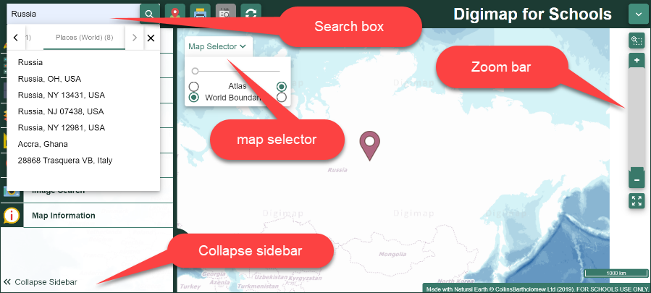
- Click on Collapse sidebar to see more of the map.
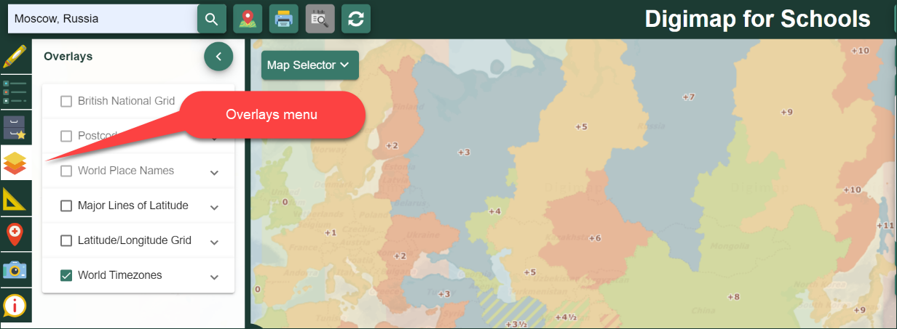
- Use the Zoom bar to zoom out and see the countries surrounding Russia.
- Record some of the countries surrounding Russia.
- Click on the map Layers in the sidebar and select World Timezones. How many timezones can you count within Russia? What does this tell you about Russia? If it is 12 noon in London what time is it in Moscow?
- Use a globe to locate Russia. What do you notice as you travel across Russia from the west to the east coast? How does this differ from the online map? What is the name of the body of water separating Russia from the USA?

Task 2 Europe or Asia?
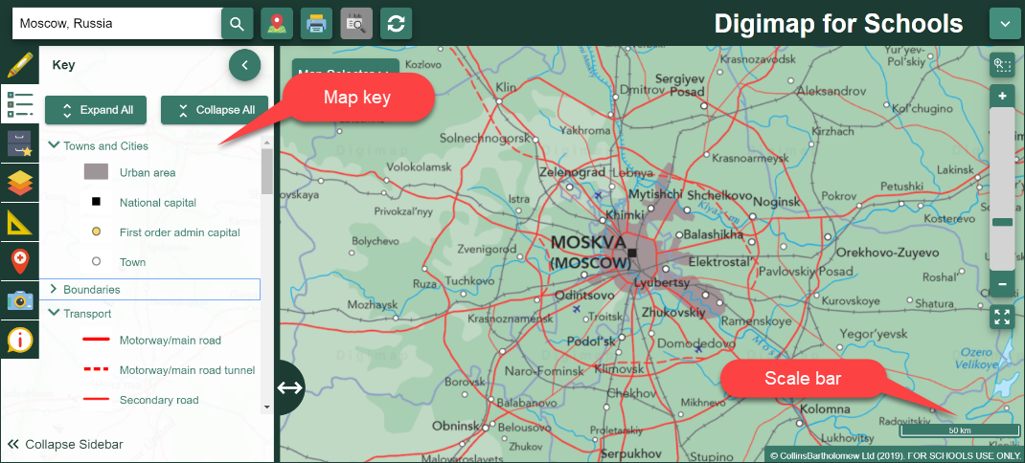
- Search for ‘Moscow, Russia’ in the search bar. Zoom in slightly and use the key to identify features of the city (urban area, towns, roads, railway, tunnel, airports, rivers etc.)

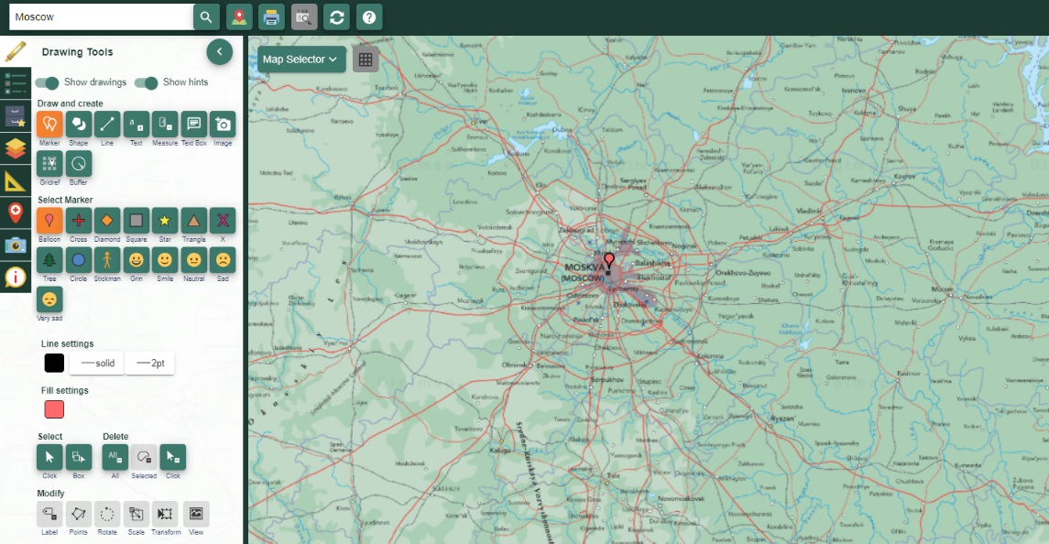
- Click on the Drawing Tools to select and place a marker on Moscow.

- Using Atlas (under Map Selector) zoom out and locate the Ural Mountains, running north to south from the Arctic Circle to north west Kazakhstan, which form part of the boundary between Europe and Asia. Where do you think most people live in Russia?

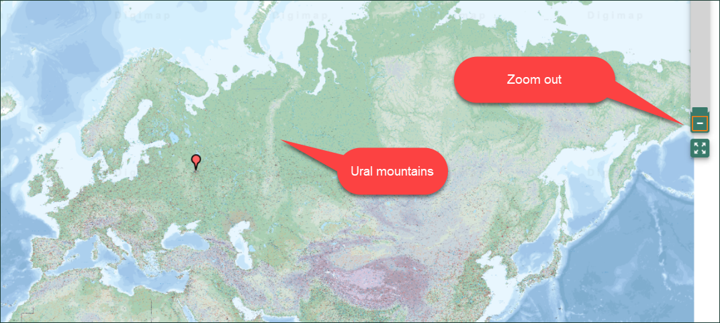
- Now search for ‘Kaliningrad’. What do you notice about Kaliningrad? (What else can you find out about this region of Russia?)

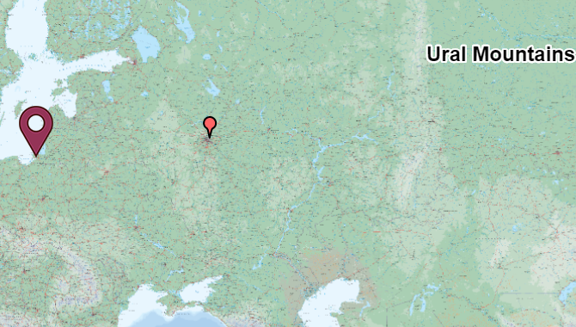

Task 3 East and West, North and South
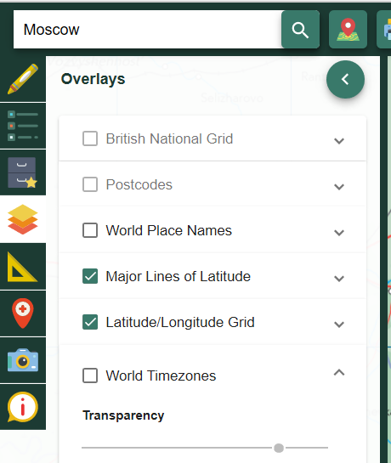
- Click on map Overlays in the sidebar and select (tick) Latitude/Longitude Grid and the Major Lines of Latitude.
- Name the 5 major circles of latitude. (Use the drop-down arrow to find out.)

- How many degrees east is Moscow? How many degrees north? These can be read on the map or click on the Map Information tool in the sidebar to find the answer.

- Travel west on your map towards the UK along the 56 degrees North line of latitude. At which major city in Scotland do you arrive? Add a marker to your map.

- Travel south along the 3 degrees West line of longitude until you find Cardiff in Wales. Add a marker to your map.
- Travel east towards London. On what line of latitude is London? Add a marker to your map. Find Greenwich and zoom in. What is special about Greenwich?

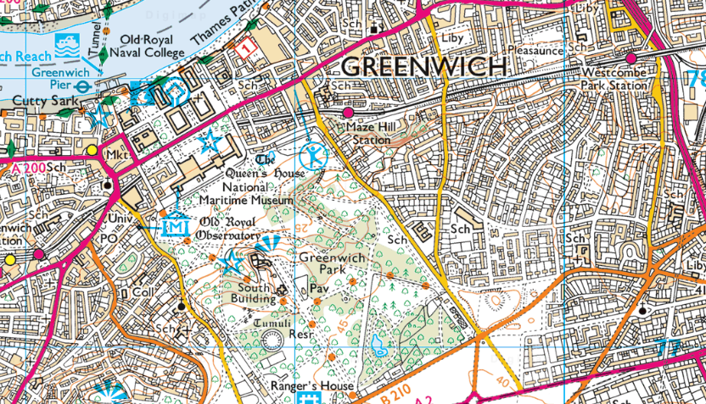
- Add other places/markers to your world map e.g. a place on the Equator, or other capital cities etc.
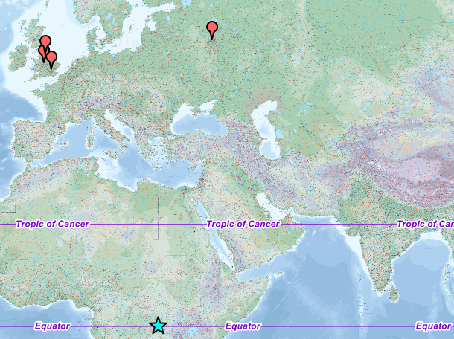
- Zoom out to view the world map. What do you notice?

Task 4 How big? How far?
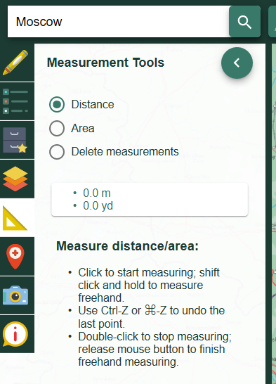
- Click on the Measurement Tools in the sidebar.
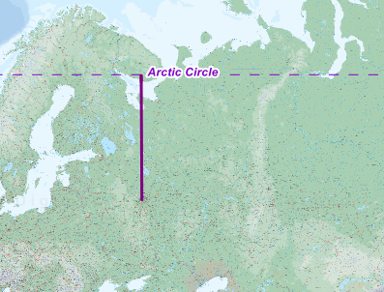
- Zoom out until Moscow and the Arctic Circle both appear on the map.
- Click on Moscow to start measuring then move north and double-click when you reach the Arctic Circle, to stop measuring. How far is it from Moscow to the Arctic Circle?

- Travel eastwards on the map. How far is it from Moscow to Russia’s east coast?

- Print off your finished map.

Copyright
©EDINA at the University of Edinburgh 2020
This work is licensed under a Creative Commons Attribution Non-Commercial Licence 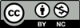

Acknowledgements
© CollinsBartholomew Ltd (2019) FOR SCHOOLS USE ONLY
© Crown copyright and database rights 2020 Ordnance Survey (100025252). FOR SCHOOLS USE ONLY.
Aerial photography © Getmapping plc. Contains OS data. FOR SCHOOLS USE ONLY.
Historic mapping courtesy of the National Library of Scotland. FOR SCHOOLS USE ONLY.

