Who goes to School by Boat?

Living on an Island, Travelling to School

Paula Owens

Geography Teaching Resource

Primary
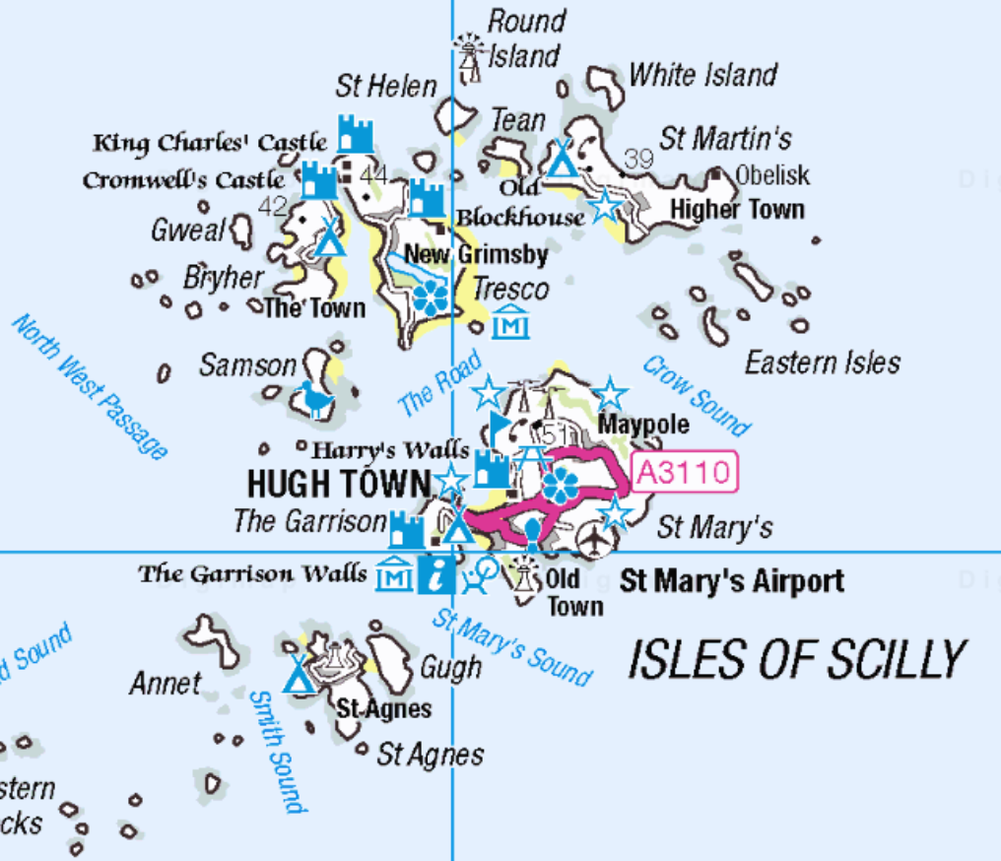

Contents
Digimap for Schools Geography Resources 3
Content and curriculum links 3
Activity 4
Introduction 4
Main activity 4
Tasks 5
Taking it further 7
Web links 8
Exploring Bryher island Name 9
Search term for Bryher using Digimap for Schools: ‘Isles of Scilly’ 9
Map of Bryher 10
Copyright 11
Acknowledgements 11

Digimap for Schools Geography Resources
These resources are a guide for teachers to demonstrate to the whole class or direct individual students as appropriate. Each activity has several ideas within it that you can tailor to suit your class and pupils. Some resources contain worksheets for direct distribution to pupils.
https://digimapforschools.edina.ac.uk/

Content and curriculum links
Level | Context | Location
Primary | Living on an island, travel to school | Scilly Isles: Bryher and Tresco

Knowledge/Skills | Reading and interpreting information from a map/measuring distance/adding annotation to a map
Curriculum links (England) | Use basic geographical vocabulary to refer to key physical and human features:  Use directional language and describe the location of features and routes on a map  Use Ordnance Survey maps to build knowledge of the United Kingdom
Curriculum links (Wales) | Knowledge and understanding of the World: Use and make simple maps, to find where places are and how they relate to other places. Geography: Use maps, and ICT to find and present locational information.
Scottish Curriculum for Excellence | Social Studies Outcomes: People, Place and Environment: 1-13b, 2-14a, 2-09a

Activity
Investigating how children who live on an island travel to school. Where are the Scilly Isles? How do people get there? What is Bryher like and where do children go to school? Pupils use maps to explore and annotate information as they answer these questions.

Introduction
The Isles of Scilly are a clustered group of 150 islands which can be found approximately 45 kilometres off the SW coast of Cornwall, mainland England. People get to the islands by boat, plane or helicopter. On the small island of Bryher, the few children who live there travel daily to the neighbouring island of Tresco by boat to attend their nearest school.
There are two main quays on Tresco: one on the east and one on the west side of the island. The eastern quay is further from Bryher yet leads directly to the school whilst the western quay is much closer to Bryher, yet further from the school. Pupils usually travel directly to the eastern quay on Tresco to go directly to the school except in bad weather when the nearer quay is used.

Main activity
Working individually or in small groups pupils investigate transport routes and create their own maps: use your knowledge of your class to select appropriate individual tasks for them to do from the list below.
There are some suggested images to support these activities and help pupils imagine what these islands are like (see web links).
You may also set this activity up by watching The Adventures of William Whiskerson (see web links).
Recap with children how they get to school then pose the question: who might go to school by boat? Gather suggestions.
Introduce the term ‘island’ if pupils are unfamiliar with this and discuss what an island is. Explain that you are going to investigate how children who live on the island of Bryher, one of many islands in the Isles of Scilly, get to school and where their school is. Ask pupils if they have heard of this place and where they think it might be.

Tasks
- Working as a class, open Digimap for Schools and enter the search term ‘Isles of Scilly’ and zoom out to show whereabouts the islands are. You could point out Land’s End, the most extreme westerly point of the mainland of England as many children may have heard of this place.

- Ask pupils to look at the map, noticing the symbols we have circled in red on the map below:
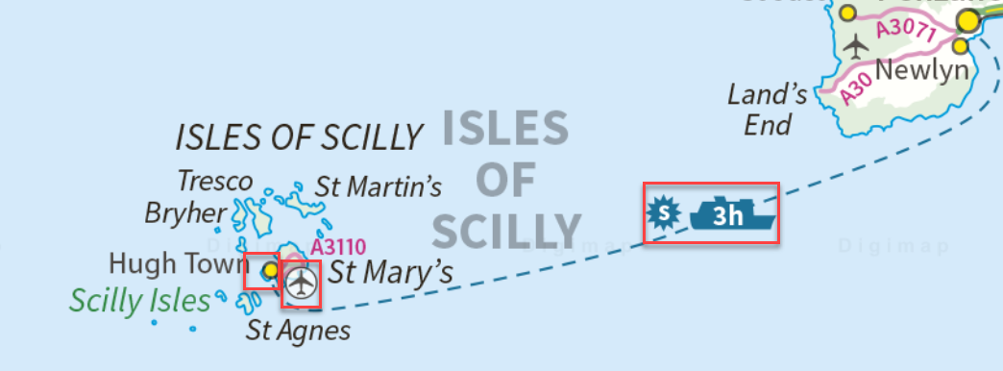

- Ask pupils to guess first what they might mean.
- Then open up the Key and ask children to look for some of the symbols, reading together what they mean. Use questions to discuss:

- How do people get to the islands?
- Where do they fly from and to?
- How long is the ferry crossing?
- Where does it travel from and to?

- Ask pupils to guess how far out to sea these islands are from the mainland. Remind them of the distance some of them travel to school to give them an idea. They can answer in either kilometres or miles.
- Then model how to use the measuring tool to measure distance choosing which points to measure from and to.
  - Open the tool, select ‘Measure distance’.
  - Click or touch first point of the route, repeat at any other points.
  - Double click on end point to see the distance in kilometres. Or check the menu on the left to see measurement in miles.

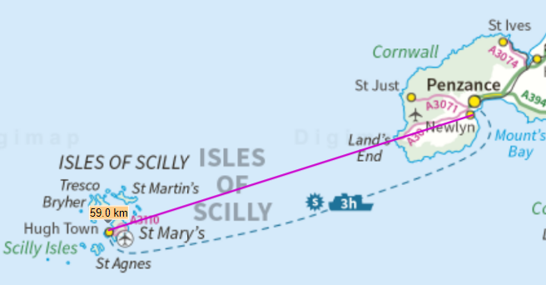
This example shows the distance from airport to airport in kms. How does that compare with the ferry?

- Zoom into the islands of Bryher and Tresco. Can you find these places?
- Quay at The Town, Bryher
- Quay at New Grimsby, Tresco
- Quay at Old Grimsby, Tresco
- The school on Tresco

- Open the Drawing tools and choose one shape to mark the position of the three quays and another for the school.
- Zoom out again until you can see both islands clearly enough to plot routes that the boats might take to travel between Bryher and the quays on Tresco.
- Use two different colours to show what you think the route might be between:
- Bryher Quay to Old Grimsby Quay
- Bryher Quay to New Grimsby Quay

- Discuss how it might feel to go by boat to school every day. What happens in really rough weather?

Taking it further
- Use a zoomed in view of Bryher to find out more about the place names on the island, or use the printable map provided. Use the worksheet provided below to find some of the more unusual names on the island, like ‘Droppy Nose Point’. Try to think of reasons for some of these names.
- Using the place names of Bryher, write a short story about being shipwrecked there and your exploration of the island.
- Find out where else in GB children might travel to school by boat and make a map to show this.
- Explore the island of Bryher by zooming into a large map view and use the Key to try and identify the features. What kind of a place is it?
- What is the landscape like?
- Are there lots of houses?
- Do they have any shops there?

Web links
- The Adventures of William Whiskerson is a BBC series showing the travels of an explorer mouse. On one of his adventures, William visits the island of Bryher to meet some children and travels with them by boat to school for the day. Watch the film and see what else you can find out about Bryher and the journey to school. Or use the film as an introduction.
www.broadcastforschools.co.uk/site/The_Adventures_of_William_Whiskerson

- Many of Michael Morpugo’s books such as Why the Whales Came and the Wreck of the Zanzibar are set in the Scilly Islands so reading extracts from these books would help to set the scene. www.readingmatters.co.uk/book.php?id=119

- Images of Bryher and nearby islands can be found in the Image Search tool in Digimap for Schools (it finds images from Geograph, an online library of images of the UK that is open to anyone for contributions).
  - Select Image Search and enter your search terms to find matching images. NOTE: you can also enter an asterisk to see all available images at a location (only in the 5 most zoomed in maps).
  - Example image - The quay at Southward, Bryher http://schools.geograph.org.uk/photo/3447707

- More general images and information about the Isles of Scilly: http://www.intocornwall.com/engine/azabout.asp?guide=Isles+of+Scilly

- You might also like to see ‘Barnaby Bear’ visiting Orkney on Class Clips for another view of island life. https://www.bbc.co.uk/programmes/p011514l

- Geographical Association (members only) can access free photo images of the Isle of Coll in Scotland www.geography.org.uk

Exploring Bryher island Name

Search term for Bryher using Digimap for Schools: ‘Isles of Scilly’
Use Digimap for Schools to find and explore the island of Bryher by zooming until you can see place names. Can you find these places and guess where they got their names from?
Write down or draw your ideas.
Watch Hill
Heathy Hill
Hell Bay
Droppy Nose Point
Moon Rock
Stinking Porth

Map of Bryher
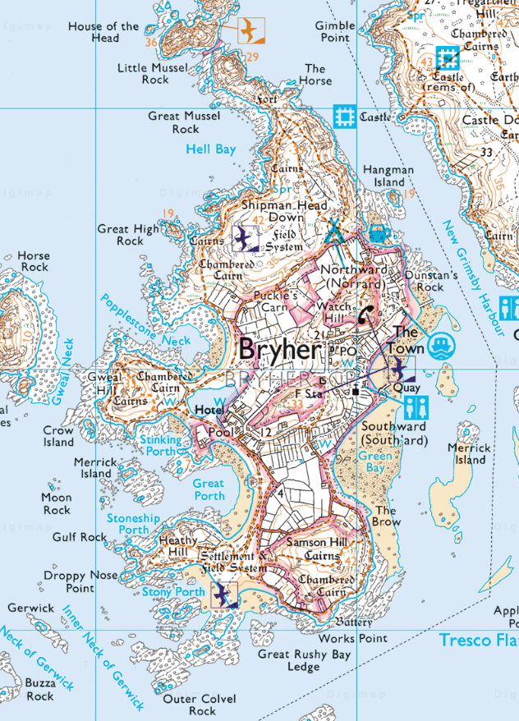

Copyright
©EDINA at the University of Edinburgh 2016
This work is licensed under a Creative Commons Attribution-Non Commercial Licence

Acknowledgements
© CollinsBartholomew Ltd (2019) FOR SCHOOLS USE ONLY
© Crown copyright and database rights 2020 Ordnance Survey (100025252). FOR SCHOOLS USE ONLY.
Aerial photography © Getmapping plc. Contains OS data. FOR SCHOOLS USE ONLY.
Historic mapping courtesy of the National Library of Scotland. FOR SCHOOLS USE ONLY.

