Conserve a wild place

Digimap for Schools and the John Muir Award.

Introduction
Digimap for Schools is an engaging cross-curricular learning resource, widely used in primary and secondary schools in Great Britain.
Our high-quality maps and engaging features help to build pupils’ digital skills while developing their geographic knowledge.
This guide is designed to introduce you to our features and how they can be used to meet a John Muir Award.

Conserve a wild place
In this challenge, it’s all action! You might decide to encourage wildlife into your place by installing bird boxes, bug hotels or planting wildflowers; maintain your place by clearing litter, removing invasive plants or planting native trees.
Digimap for Schools can be a useful tool in this challenge in several ways; to make a site plan, to measure areas of your site, to outline activities such as surveys and litter picks and to record your work.

Contents
Introduction 2
Conserve a wild place 2
Contents 2
Site plan 3
Measuring areas 4
Collecting geographic points 5
Collect the data 5
Data formats accepted 5
Creating a CSV file 6
Import to your map 6

Site plan
A map of your plans for your place can be useful in both planning the work and engaging pupils.
- Digimap for Schools has OS MasterMap® mapping, which is the most detailed mapping that Ordnance Survey produce for Great Britain. Zoom in as far as possible to see these detailed maps.
- Adding images brings the plan to life.

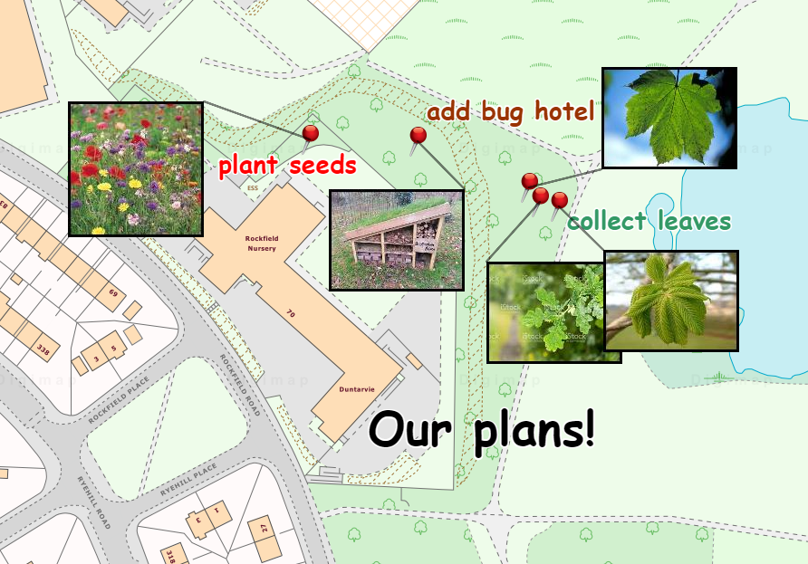

Measuring areas
Our Drawing Tools have a measurement label option. You can add measurement labels to distances or areas, for lines or shapes YOU HAVE ADDED to your map.
- Open the Drawing tools.
- Draw a shape or line.
- Select the Add measurement label option.
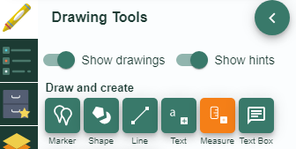
- Select your line or shape, to add a label.
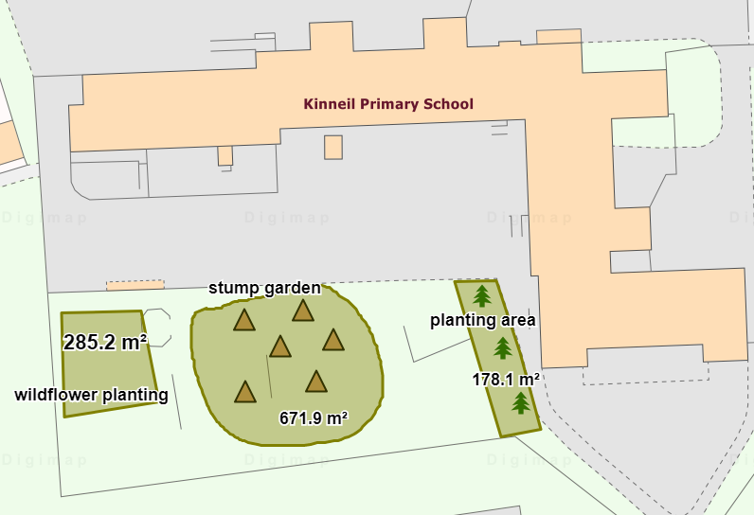

Collecting geographic points
You can collect a list of geographic points and add them to your map. Potential uses could be to record:
- Points where litter was found
- Sightings of birds or insects
- A route
The image below shows the result of importing points where litter was found.
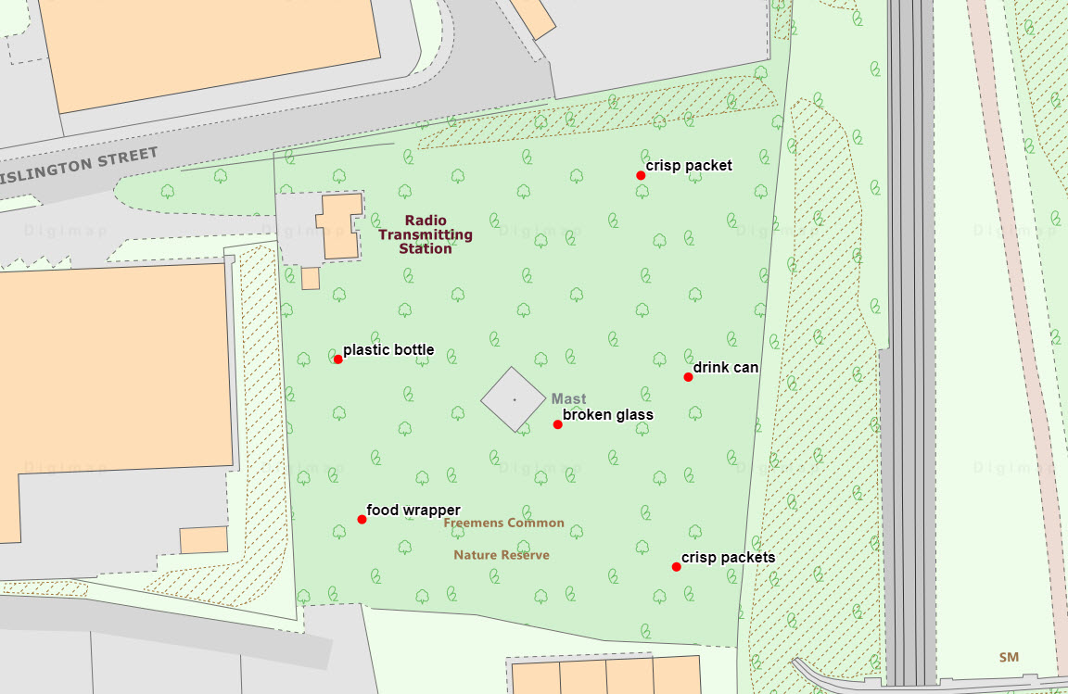

Collect the data
You can collect and import four types of geographic data; Postcodes, Easting/Northing, Latitude/Longitude, Ordnance Survey Grid References.
There are lots of apps available to help you collect data in the field. It should be possible to download the records you collect and then import the downloaded file to Digimap for Schools.

Data formats accepted
You can import data files in these formats:
- CSV file - easy to create in any spreadsheet package.
- GPX - created by GPS devices.
- Shapefile - a commonly used geographic data file format. For example, you can export survey results from ESRI’s Survey123 app as Shapefile format.
- KML - Google Earth format.
- GeoJSON - a commonly used geographic data file format.

Creating a CSV file
If you wish to create your own simple spreadsheet to import, you will find instructions on our help pages.

Import to your map
- Select Add Data from the menu on the left.
- Select Choose File.
- Find your file and select Open.
- Finally select Import.
- Your points should be visible on your map.

This resource is licensed under a Creative Commons Attribution-NonCommercial-ShareAlike 4.0 International License.

