Discover a wild place

Digimap for Schools and the John Muir Award.

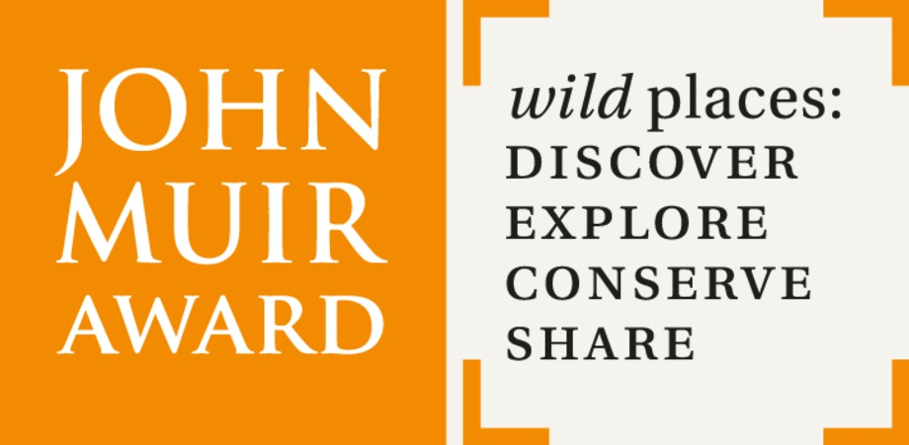

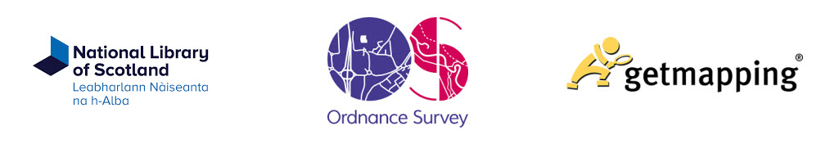

Introduction
Digimap for Schools is an engaging cross-curricular learning resource, widely used in primary and secondary schools in Great Britain.
Our high-quality maps and engaging features help to build pupils’ digital skills while developing their geographic knowledge.
This guide is designed to introduce you to our features and how they can be used to meet a John Muir Award.

Discover a wild place
In this challenge you will identify your wild place. This could be within the school grounds or further afield such as a local park, woodlands or national park. In choosing your place, the John Muir Trust handbook asks you to consider your place’s natural character and what makes it special or interesting.
Digimap for Schools can help you find out what’s nearby and identify its features.

Contents
Introduction 2
Discover a wild place 2
Contents 2
What’s nearby? 3
Buffer zone 3
What’s at the place? 4
Image search 5
Measuring distance 7
Recording possible places 7
Labels 7
Symbols 8
Saving your maps 8

What’s nearby?

Buffer zone
You can try adding a buffer around your school to see what lies within a certain distance.
- Find your school.
- Open the Drawing Tools from the menu on the left.
- Select the Buffer option, choose point, then select a distance.
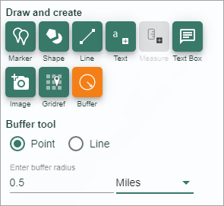

The map below shows a buffer of 0.5 miles around a school.

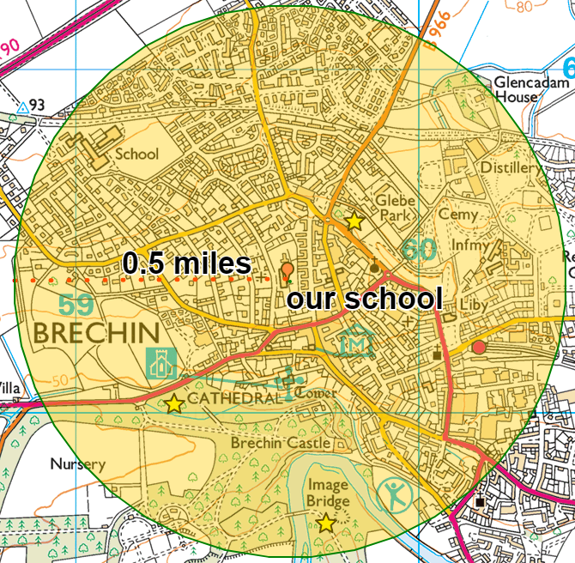

What’s at the place?
What features are there? Use the map keys (legends) to start gathering useful information on what’s at your place. You could look at:
- Land features e.g. type of woodland
- Water features
- Any archaeological sites
- Tourist information
- Heights and contours
- Public access
Select Key from the menu to the left of your map:
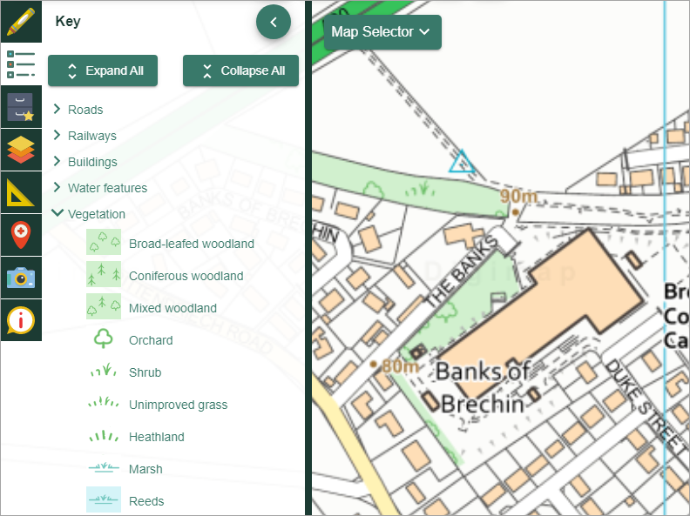

Do remember that the map keys often change as you zoom in and out.
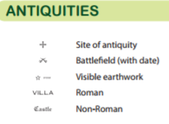
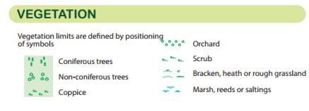
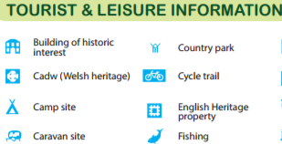
Print off A3 maps of the area and give them to pairs or groups of pupils, along with a specific area of the map key, e.g. one group could look for Vegetation. Ask them to highlight matches and then report back verbally on what they find.

Excerpts from the map key for OS Explorer maps

Image search
You can search for all Geograph photos at potential places, to start visualising locations. Geograph is a project that aims to collect photographs of every grid square of Great Britain and Ireland. You can view all the images (almost 6 million!) in Digimap for Schools.
- First, open the Image Search tool from the menu on the left.
- Enter an asterisk * to find all photos and select Enter. NOTE: you can only search for all photos when you are in the 5 most detailed maps.

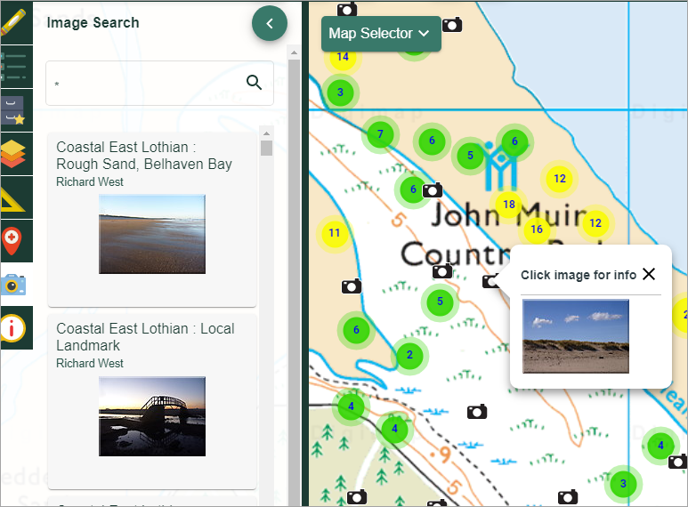

- For a more specific search, you can use any search term you like. As you type, suggested terms will be presented.
- If you don’t find any images…make it your mission to take lots of photos of your place and add them to Geograph!
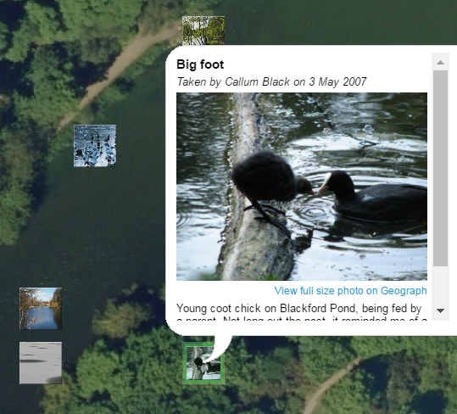

Measuring distance
To measure how far a location is from school, try our measurement tools.
- Select the measurement tool from the menu on the left.
- Select the distance option is selected.
- Click on the map at your starting point.
- Click at each point you wish to measure and double click at your end point.
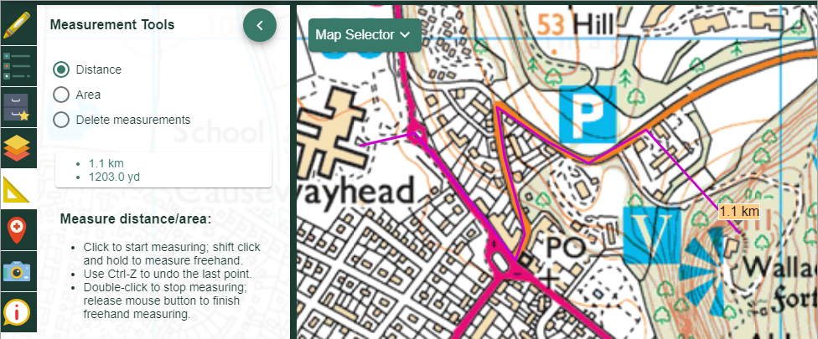

Recording possible places
Digimap for Schools’ Drawing Tools allow you to add shapes, text, symbols and measurement labels to your maps. Add labels and/or symbols to your map to identify possible wild places.

Labels
- First, select the Drawing Tools from the menu on the left.
- Select the Add a text label button.
- Select a text colour, font and size.
- Click on the map where you want to place your label.
- Type your label text and select Add.

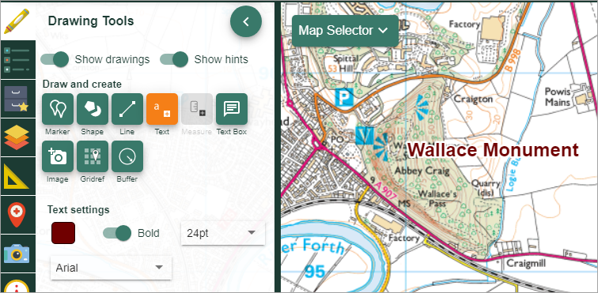

Symbols
- To add symbols, just select the Marker tool.
- The marker options pop up below.
- Select your symbol of choice.
- Click anywhere on your map to add the symbol.

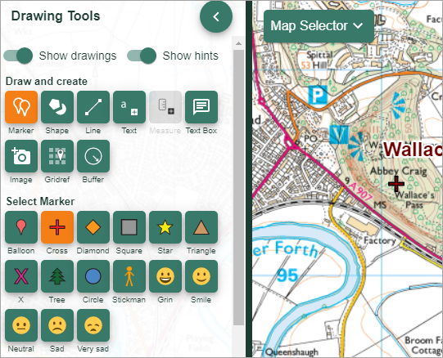

Saving your maps
Remember to save any maps you create, so you can use them I the different challenges.
- Select the Save menu on the left.
- Select Save map.
- Enter a Map title, your name and class.
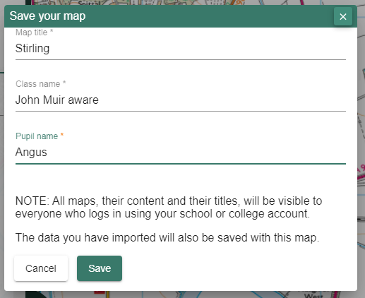
- To view a saved map, just select it from the list.

This resource is licensed under a Creative Commons Attribution-NonCommercial-ShareAlike 4.0 International License.

