Explore a wild place
Digimap for Schools and the John Muir Award.

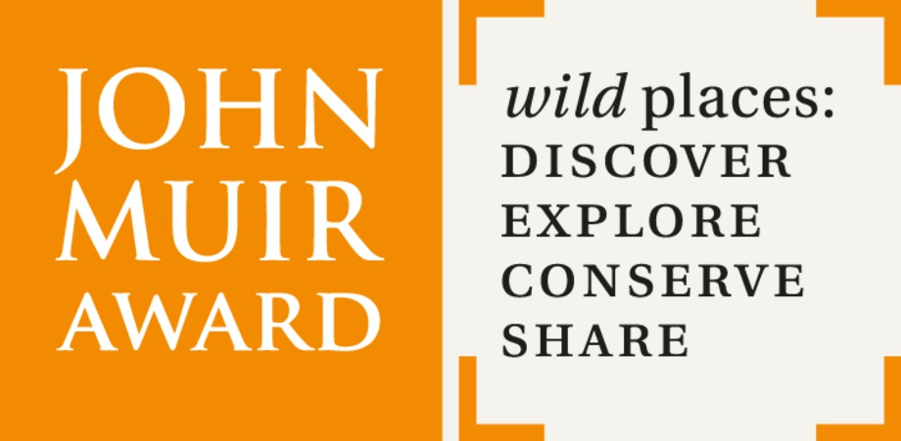

Introduction
Digimap for Schools is an engaging cross-curricular learning resource, widely used in primary and secondary schools in Great Britain.
Our high-quality maps and engaging features help to build pupils’ digital skills while developing their geographic knowledge.
This guide is designed to introduce you to our features and how they can be used to meet a John Muir Award.

Explore a wild place
In this challenge, you will increase your understanding of your place. Digimap for Schools can help you plan your route, develop your map skills, research the history of your place, examine the place’s physical features and see what you can do there.

Contents
Introduction 2
Explore a wild place 2
Contents 2
Make a BEFORE map 3
Adding photos 3
Aerial and Historic maps 4
Comparing maps 4
Getting there 6
Map skills 7
Surveys 9
How high? 10
Relief and contours 10
Activities at your place 11

Make a BEFORE map
Make a map of your place before you start. Use the Drawing Tools to highlight any features that made you choose it and give details of things you might do to explore or conserve it.
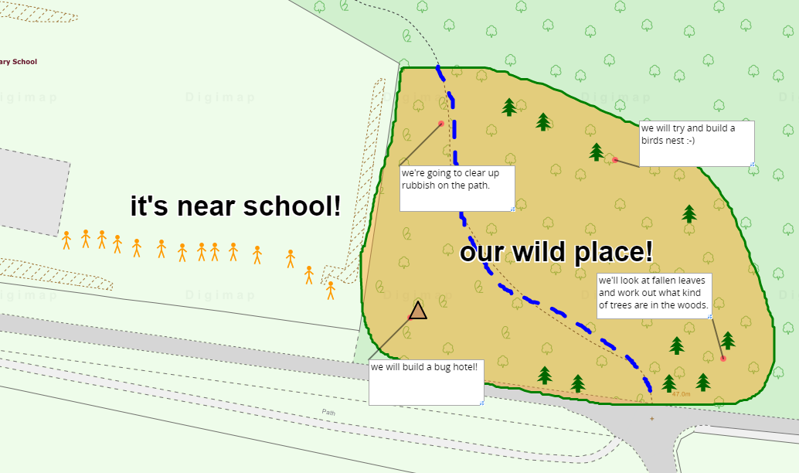

Adding photos
As you progress through the John Muir Award, hopefully you will gather lots of photos of your wild place and the work you do there. Add these to your maps in Digimap for Schools.
- Open the Drawing Tools and select the Add Photo option.
- Select the spot on your map you want to put your photos.
- Select Choose File.
- Find your photo on your computer or tablet.
- Select Upload.
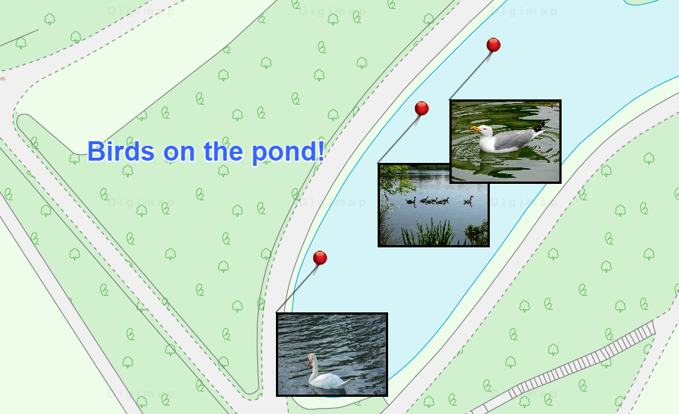

Aerial and Historic maps
Remember that aerial and historic maps are available in Digimap for Schools. These can add real depth to your research.

View an aerial map
- Find your location, then open the Map Selector on the map window.
- Select the Aerial button on the right. (AerialX offers the same aerial map but with the addition of road and place names).

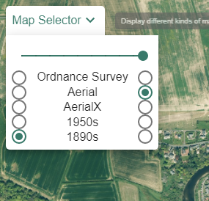

View historic maps
- Find your location, then open the Map Selector on the map window.
- Select the 1950s or 1890s button on the right.
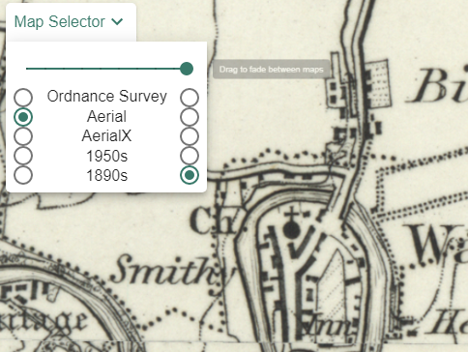

Comparing maps

On screen
You can move the slider bar in steps, to compare, for example, a contemporary map with an aerial one. This can also be useful to get an idea of development between two periods.
- Just select the maps you want to compare, one on the left and one on the right.
- Now move the slider bar in steps to fade between the 2 maps.
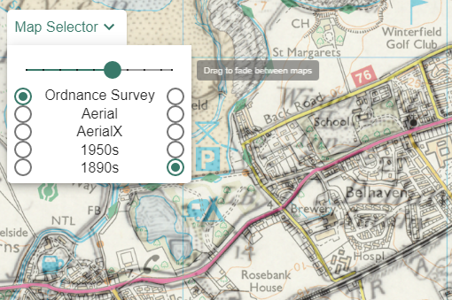

On paper
Why not print A3 contemporary and historic maps and get pupils to work in pairs or small groups to spot the difference between them?
You could prompt pupils to look for differences such as more houses, less open space, historic industries such as coal and quarries, more roads etc.

Getting there
Plan your route. Use the Drawing Tools to draw lines, add measurement labels (to lines and shapes) and text labels to your map.
To print your map with grid lines, just tick the Add Grid Lines box on the left of your map, in the Print area.

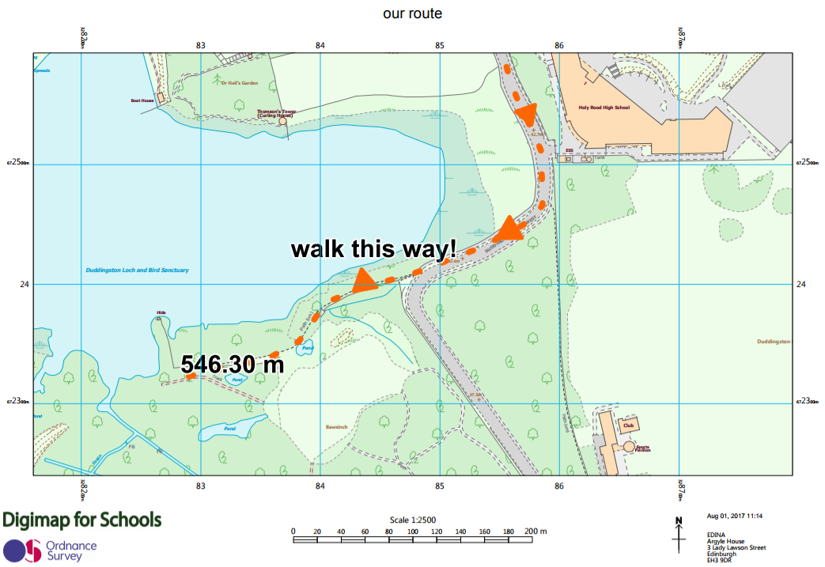

Map skills
The Ordnance Survey has a range of resources to help your pupils develop map skills and geographic knowledge: https://www.ordnancesurvey.co.uk/education/
Digimap for Schools offers functions to complement these resources. To reinforce learning on grid references, for example, print a map of your area with grid lines. Use different coloured pens or stickers to mark several points on the map. Ask pupils to identify grid references for these points.
You can then check your references within Digimap for Schools.

Identify grid references
- Select the Drawing Tools from the menu on the left.
- Select the Place Grid Reference tool.
- Select anywhere on your map to add a grid reference for that point.
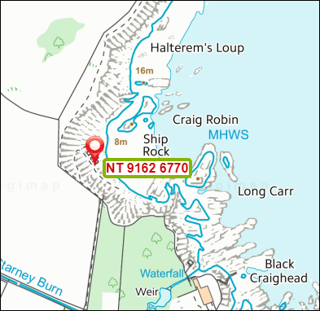

View National Grid lines
- Select Overlays, then British National Grid Lines.
- Your map window will now display British National Grid lines.
- As you zoom in, progressively more detailed grid lines appear.
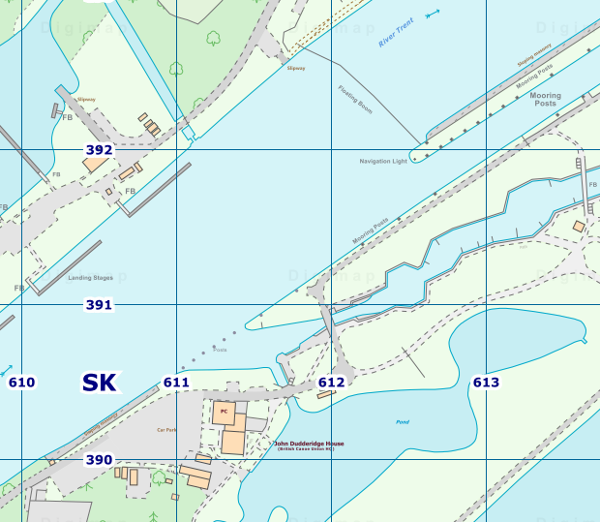

Surveys
Decide what you want the pupils to look for and record; leaves, berries, insects, birds, trees, for example. The Woodland Trust has some great activity ideas and downloadable spotter sheets for younger pupils, to help them identify what they see.
You could use the Drawing tools to mark off different areas; in the map below, we have sectioned off areas where different groups will look for birdlife.

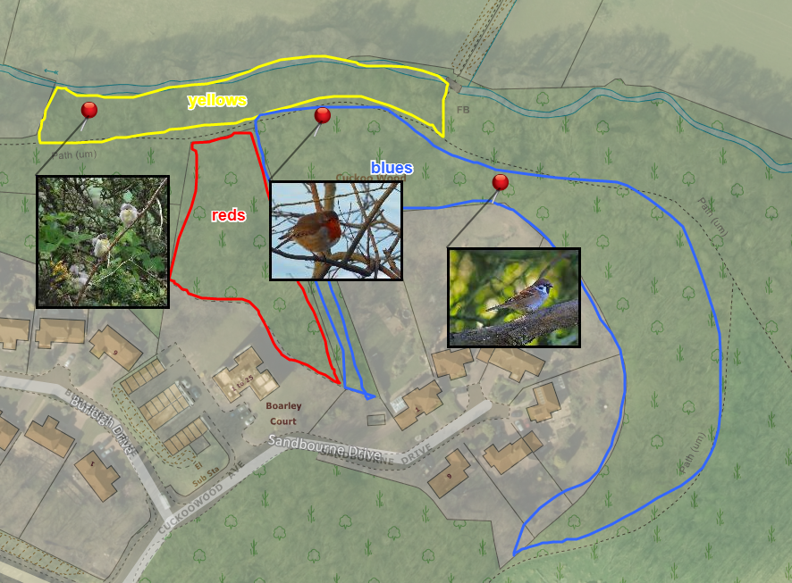

How high?
Print a map with contour lines and spot heights. You can find contour lines and spot heights on the OS Explorer and OS Landranger paper maps. In Digimap for Schools, the equivalent digital maps are shown at zoom levels 5, 6 and 7.
Work with pupils to identify spot heights on maps of your wild place. Can they find the highest point in your wild place? Compare it to some landmarks, such as Big Ben (97m). Introduce some numeracy – how many times would they have to walk around their wild place to get to the top of Ben Nevis, for example?

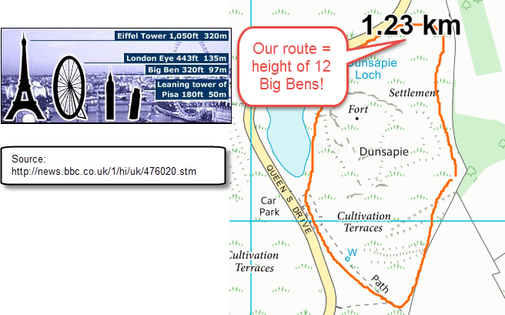

Relief and contours
Ordnance Survey’s Mapzone has a simple introduction to relief and contours: https://www.ordnancesurvey.co.uk/mapzone/map-skills
Before you visit, try and identify any contour patterns at your wild place. Cliffs, ridges, valleys? Does your route take you uphill? Are there areas that are steep? Do you need to allow more time to reach your place?
Take your maps with you and try to match contours to what you see – you may be able to recognise contour patterns.
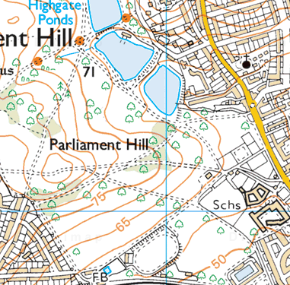

Activities at your place
Use our map keys to help you learn symbols for walks, national trails, cycle routes and tourist and leisure information.
- Select Key from the menu on the left to see the key for your current map.
- Print keys by selecting Add Legend from the Print options.

This resource is licensed under a Creative Commons Attribution-NonCommercial-ShareAlike 4.0 International License.

